Student Companion

User Manual

COMP-SCI 5551 Advanced Software Engineering

Group 7

Sri Harsha Chennavajjala (7)

Teja Garidepally (12)

Raj Kiran Reddy Munnangi (32)

Suhas Sai Raparthi (51)

# Introduction

This guide is written for students who use Student Companion application. The application enables the students to login with their details and manage their tasks.

With this application you can:

* Create a profile with your personal information and keep your account secure with a password.
* View your class schedule and be informed about the tasks associated with the courses taken.
* Access lab information and know the availability of the systems.
* Reserve/Cancel a study room for a time slot using calendar view.
* View your shift schedule and can take any available shifts.

# Setting Up

Before downloading the app you must be a current enrolled student in UMKC. This gives you the access to login with your student sso details.

# Device constraints

The Student Companion Application supports devices on Apple iOS 8.0 or later and Android with connectivity from a wireless carrier or Wi-Fi provider. This can also be accessed through web browser.

# Sign Up

When you open the student companion app for the first time, you need to register from login page as shown below:

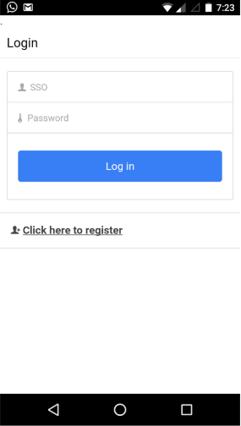

Click the register link, where you can complete your profile and register yourself to login into the app. All the details must be filled with correct information and choose a secure password with minimum of 8 letters. Then proceed to click register.

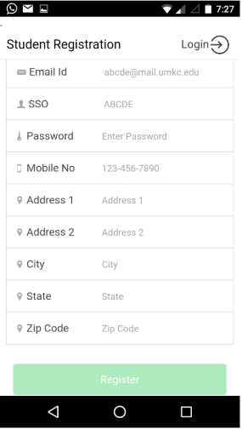

After successful registration you will be redirected to the login page.

# Login Page

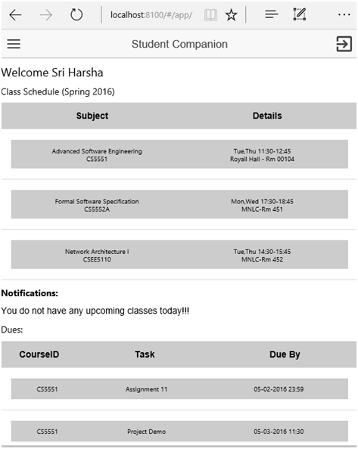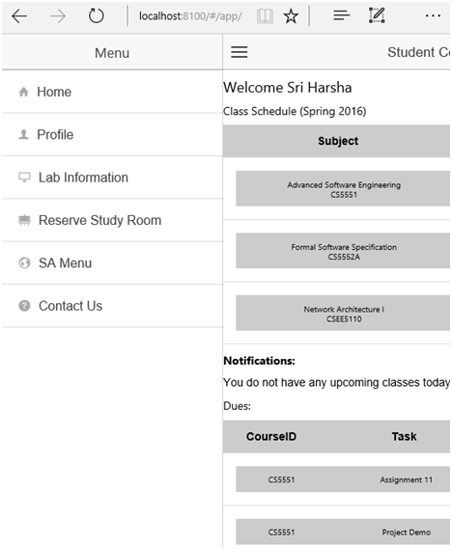Log-in to your account by giving your sso id and password. A home page pops up with a side menu, displaying your current class schedule and notifications.

**Fig: Home page**

**Fig: Side Menu**

Lets’ explore the different options we have in our side menu.

# Profile

The profile section has the complete information about you, which you have filled at the time of registration. It has the options to update profile information and your password.

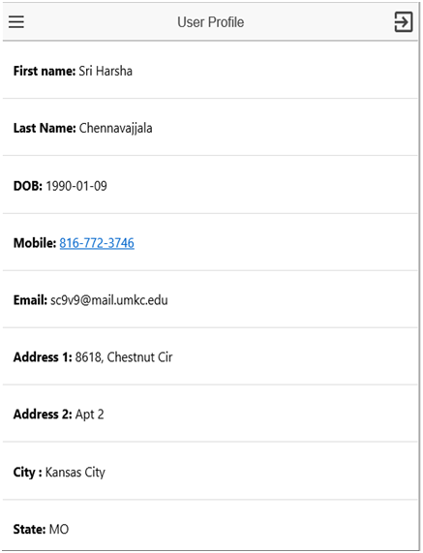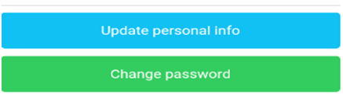

When there is a change in your personal details, you can click on “update personal info” tab and update your details.

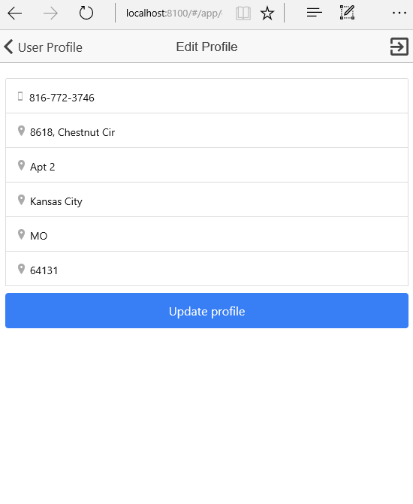

Periodic change of password is important to maintain the security of your account. You can change your password and keep it updated from the “change password” tab provided. To update the password the existing password must be entered along your new password.

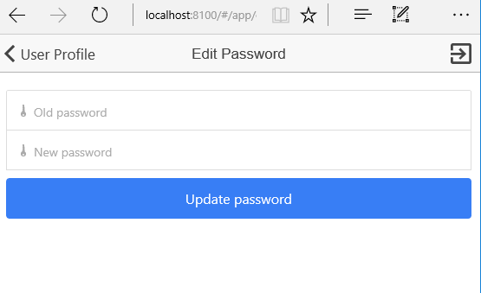

# Lab information

The labs information section shows you all the available labs in a list view. When you select a lab, you’ll see the details like location, capacity, working hours and reservations for next week.

**Fig: Lab information**

**Fig: Lab details**

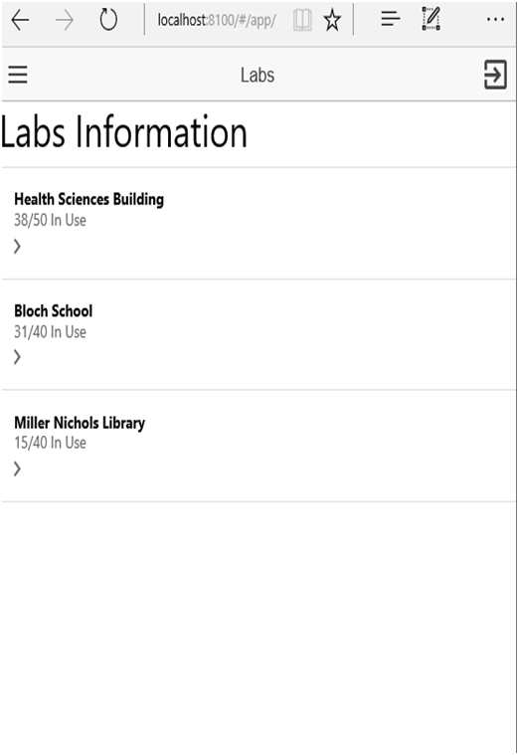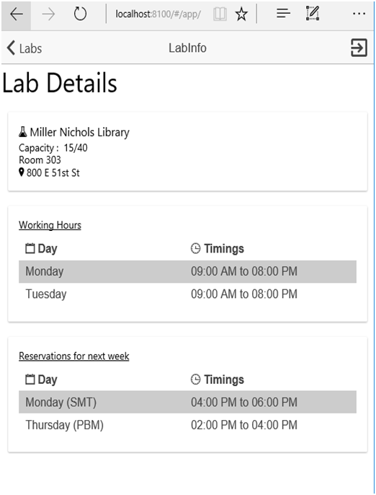

# Reserve study room

This section allows you to reserve a room for your group studies. You can view all your reservations from the “view my room reservations” tab.

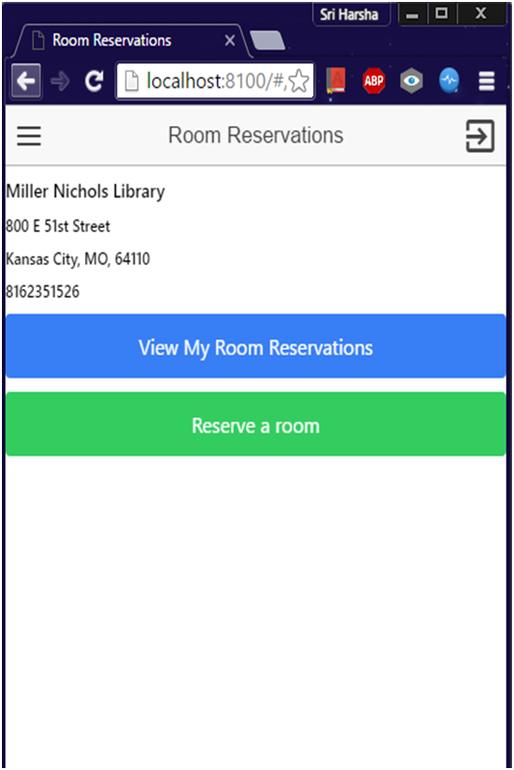

**Fig: Room reservations**

**Fig: My room reservations**

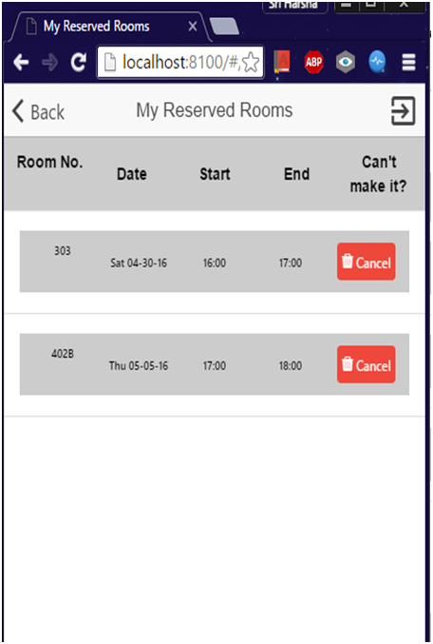

**To reserve a room:**

**Step 1:** go to reserve study room tab from the side menu

**Step 2:** click “reserve a room” option

**Step 3:** a list view appears with the available rooms. Click the select option

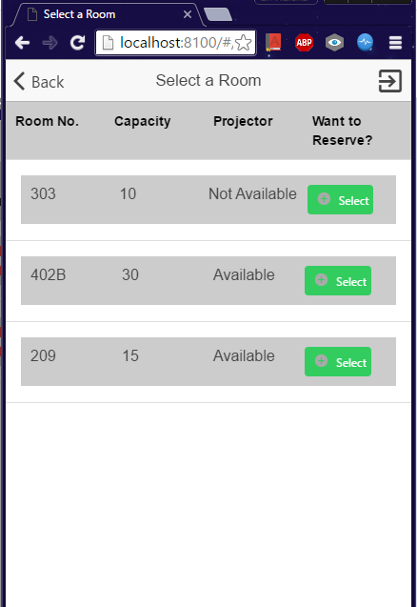

**Step 4:** a calendar opens to select the date

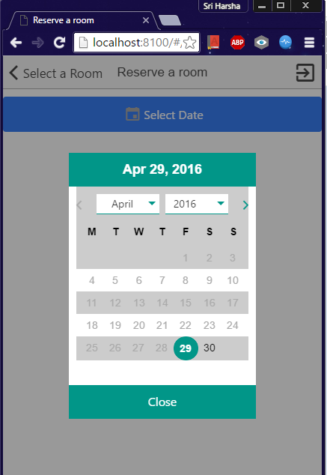

**Step 5:** a list of available time slots open for your selected date

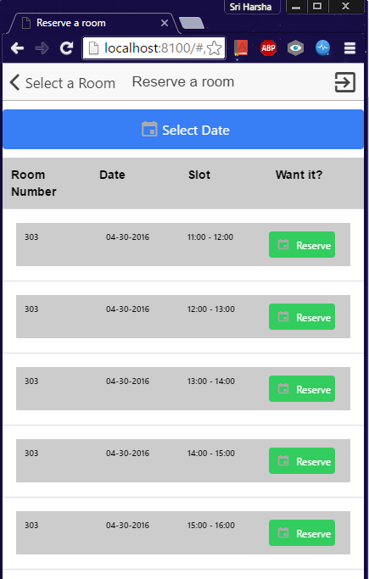

**Step 6:** click the reserve option for your desired time slot

**Step 7:** a confirmation page pops. Check your details and submit

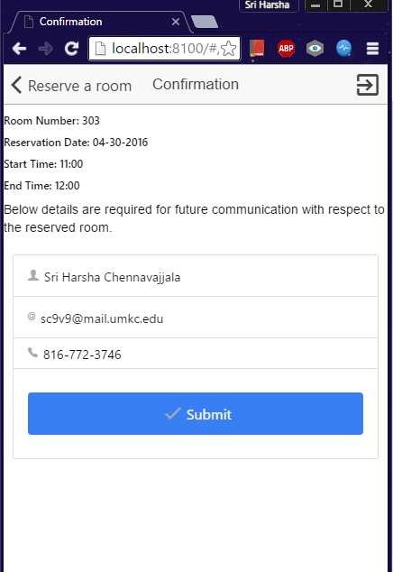

If there are any alterations in the schedule, the lab coordinator contacts you through mail.

**To cancel a room reservation:**

**Step 1:** go to “reserve study room” tab and click “view my room reservations”

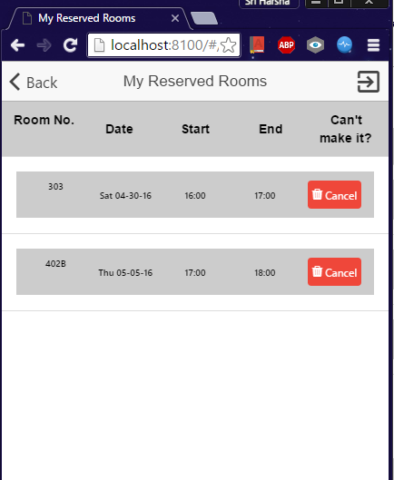

**Step 2:** select the cancel option for your desired time slot

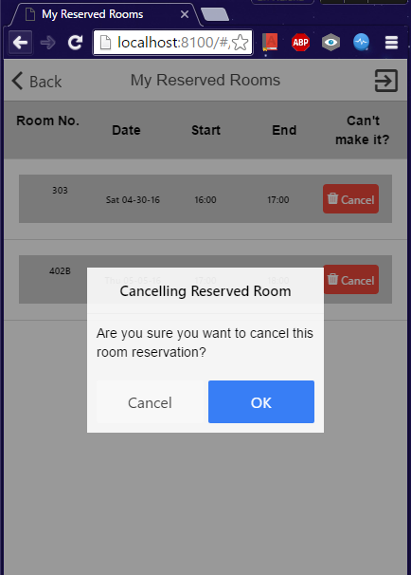

**Step 3:** click ok to confirm

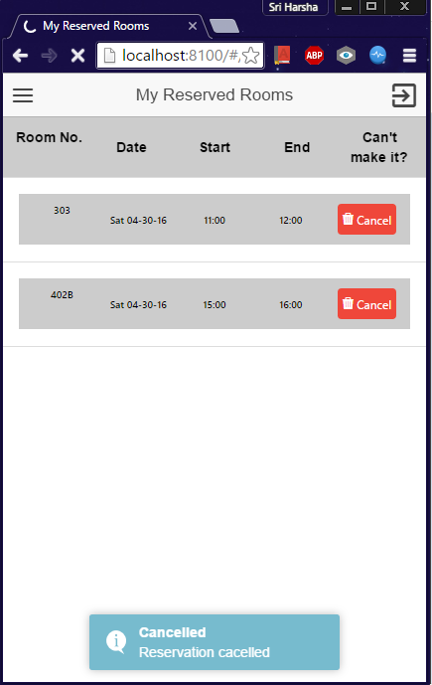

# Student Assistant Menu

Students who work for IS labs can see their assigned shifts in this section. If any substitution slots are posted, you can take those shifts by selecting the particular slot from the list.

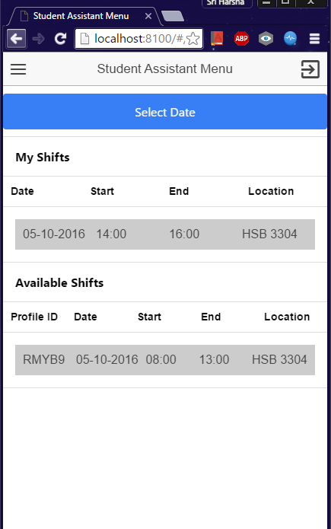

**To post shift:**

**Step 1:** go to “student assistant menu” tab

**Step 2:** select date

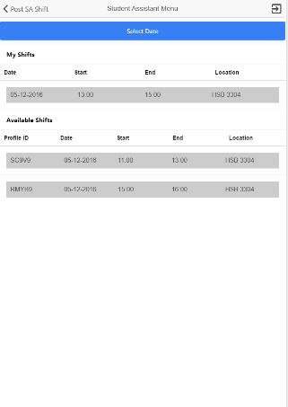

**Step 3:** enter the time and confirm.

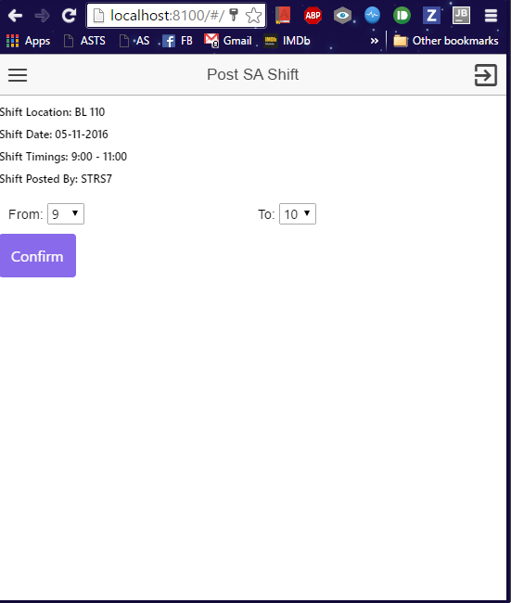

**To take shift:**

**Step 1:** go to “student assistant menu” tab

**Step 2:** select date and check for available shifts

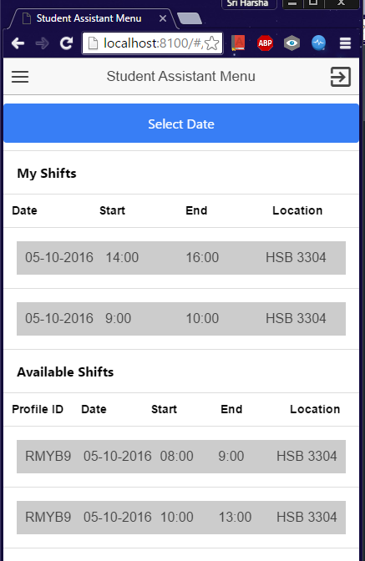

**Step 3:** select the time slot and click confirm

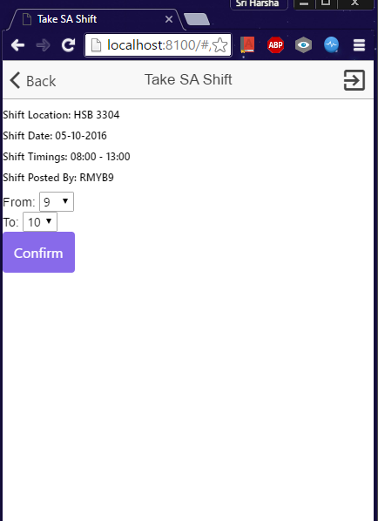

# Support

The section “contact us” has the details to contact the call center for any queries or problems.

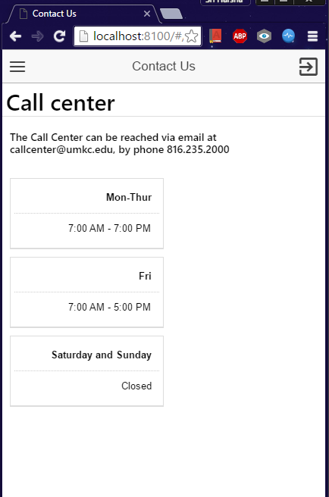

# Deficiencies

You cannot:

* delete your account
* add a profile picture
* add yourself to a waitlist for reserving a room

Student Companion

Project Management Report

COMP-SCI 5551 Advanced Software Engineering

# Introduction

This document is intended to provide an overview for the management of project named “Student Companion”. The task management is also discussed. The outcome of the project management report is how the project is divided in to tasks among group and how each task is managed.

# Project Goal and Objectives

The goal of this project is to provide various functionalities that a student uses regularly such as updating the profile, checking for computer lab availability, library study room reservation etc. The student details will already present in the database. The student has to login before he uses these functionalities. Main objectives of this application are:

* To reduce the student’s stress and to save the student’s time by providing the latest availability of the computer labs.
* To develop an application that helps the students in taking the decision on to which laboratory the students have to go.
* To secure the information by providing a login form to the end user.
* To provide a tool with which the students will be able to reserve the library study rooms.
* To ensure that the student will never miss his schedules by setting reminders.
* To enable the Student Assistants to view their shifts, post and take substitutions.
* To provide the students with the option to update their address or mobile phone number etc.

# ZenHub:

We use ZenHub a browser extension that adds robust project management features directly into GitHub’s UI, making centralized collaboration on GitHub faster, more visual, and less cluttered. It provides agile project management for the project and helps to visualize the tasks performed through burndown charts and graphs.

# Project Plan

The project is divided into four milestones. Each iteration has several states namely future tasks, new issues, to do, development in progress, testing in progress, done and closed.

# Milestone 1

**Duration:**

Start: February 1, 2016

End: February 21, 2016

Days: 21

**Task done:**

This milestone mainly deals with the designing the system for the implementation phase. The tasks of this phase mainly focuses on the UML diagram and collecting the necessary requirements details for the realization and development of the application.

**Task responsibility:**

All the four members of the team collectively completed the task.

**Issues:**

There are no particular issues.

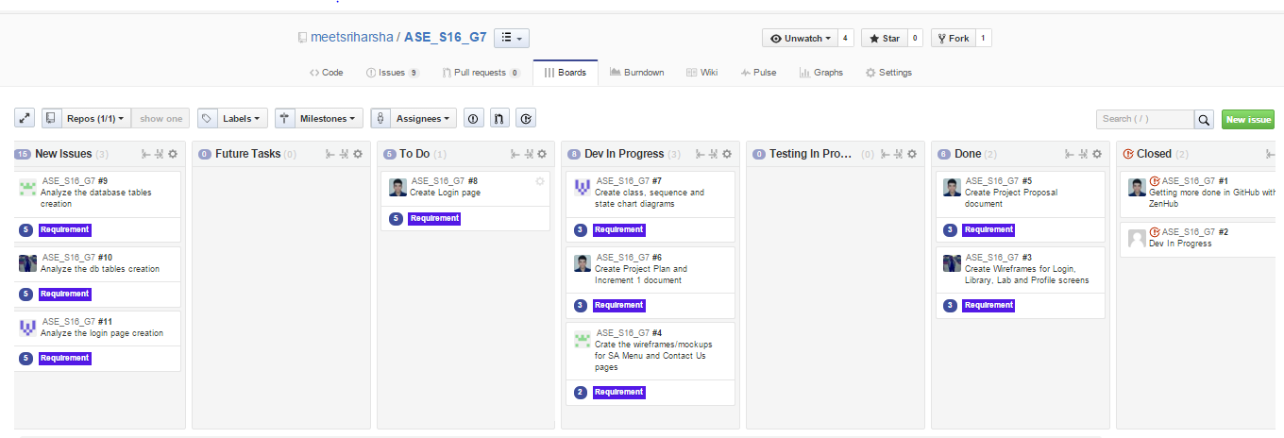

**Fig: ZenHub Board showing the project plan and current tasks.**

**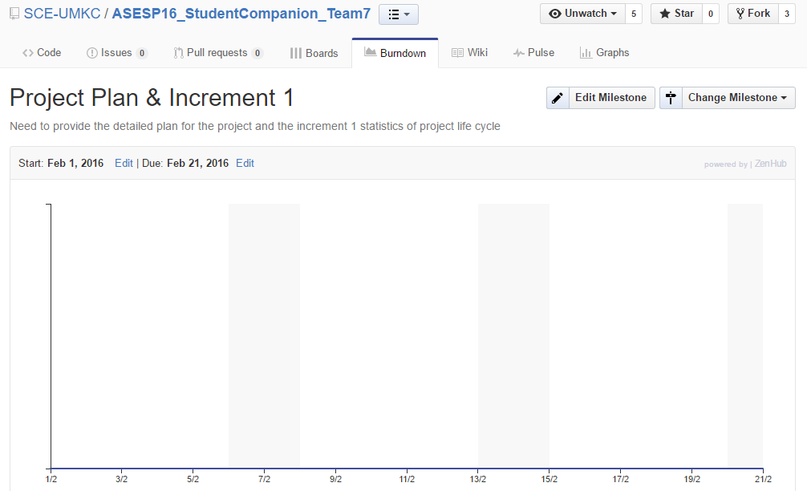**

**Fig: Burndown chart for Milestone 1**

# Milestone 2

**Duration:**

Start: February 22, 2016

End: March 11, 2016

Days: 19

**Task done:**

This milestone mainly deals with the designing the system for the implementation phase. The tasks of this phase mainly focuses three tasks.

First, the development of basic blue print of application using wireframes which gives pleasant UI to the user.

Second, development of login page and authentication of user using his/her credentials which are stored in the mongoDB.

Third, creation of database using mongoDB , populating the database and accessing the database using monoDB API.

**Task Responsibility:**

Development of wireframes is done by Raj Kiran Reddy and Suhas.

Second, development of login page and authentication of user using his/her credentials is done by Teja and Sri Harsha.

Database part is done by Sri Harsha.

**Issues:**

Issues are regarding database access whether to use an API or to use driver to access data from the mongoLab and this issue is resolved in milestone 3.

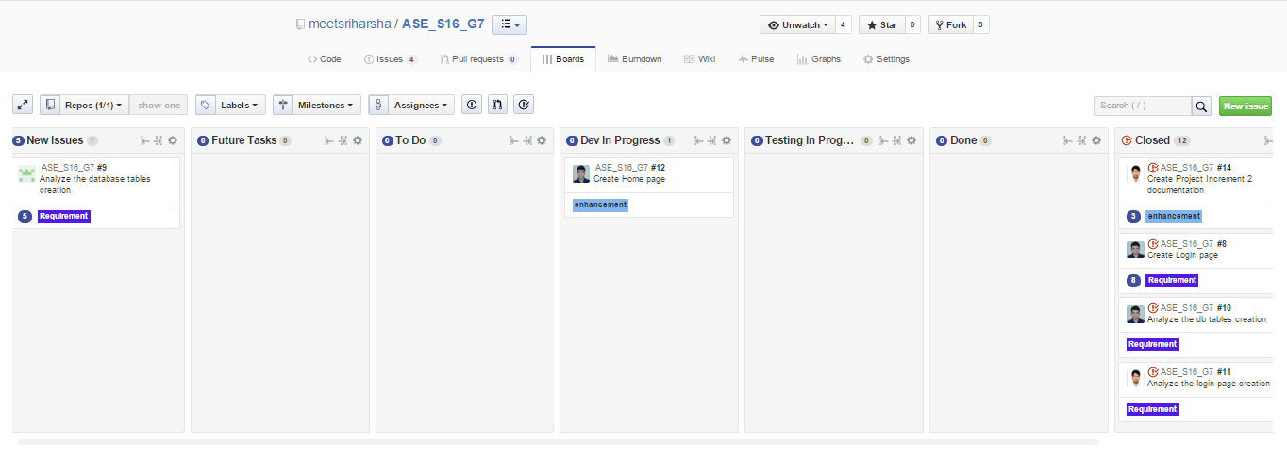

**Fig. ZenHub Board showing the project plan and current tasks**

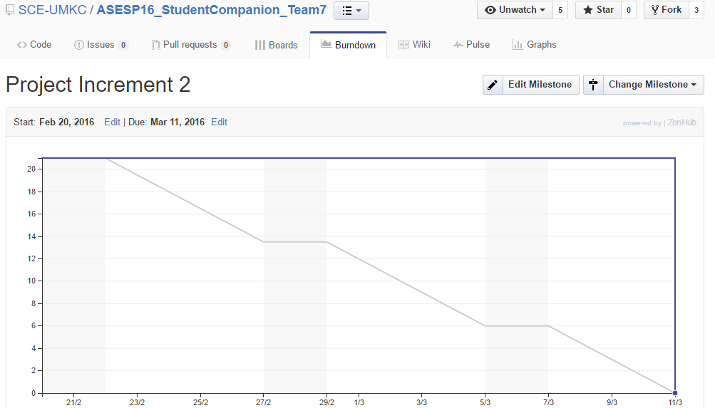

**Fig: Burndown chart for Milestone 2**

# Milestone 3

**Duration:**

Start: March 12, 2016

End: April 6, 2016

Days: 26

**Tasks Done:**

This milestone mainly deals with the designing the end to end functionality of the system. The tasks of this phase mainly focuses six tasks.

First, the development of REST API which performs the communication between Client application and database.

Second, development of View profile page and displaying the profile of the user which is stored in the mongoDB, registration page and its functionality and contact us page with contact information related to IS call center.

Third, development of Lab Information page and display the Lab name, available work stations and systems which are in use in that lab.

Fourth, development of Reserve Study Room page and display the Library information, study rooms which are reserved by the user and available study rooms.

Fifth, development SA Menu page and display the SA Shifts of the user on a or after a particular date.

**Tasks Responsibility:**

First and fourth tasks are done by Sri Harsha.

Second task is done by Teja.

Third task is done by Suhas.

Fourth task is postponed to the next increment as it has some complex logic to implement.

Fifth task is partially done by Raj Kiran Reddy and remaining work is continued to the next increment.

**Issues:**

Issues are regarding static database and it is ignored and continued forward. Implementation of REST API and deploying it in the Amazon Web Services has taken long time as each and every line of the code has to be tested in incremental state.



**Fig: ZenHub Board showing the project plan and current tasks**

**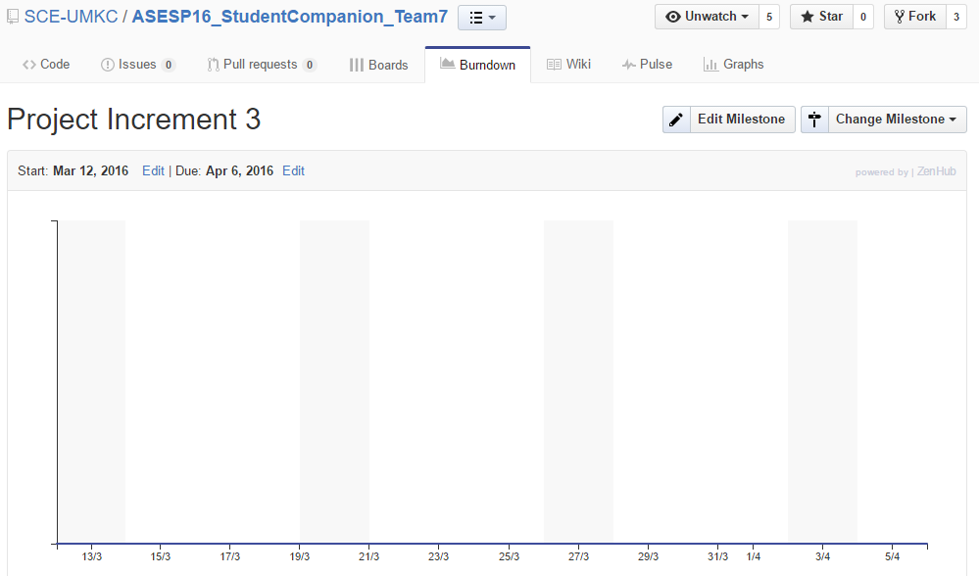**

**Fig: Burndown chart for Milestone 3**

# Milestone 4

**Duration:**

Start: April 7, 2016

End: April 29, 2016

Days: 23

**Tasks Done:**

This milestone mainly deals with the designing the end to end functionality of the system. The tasks of this phase mainly focuses six tasks.

First, the development of REST API which performs the communication between Client application and database.

Second, development of View profile page and display the profile of the user which is stored in the mongoDB. Developed the full functionality for registering user and added validations to registration page. Developed editing profile page and editing password of user with complete logic.

Third, development of Lab Information page and display the Lab name and lab details.

Fourth, development of Reserve Study Room page and display the Library information, study rooms which are reserved by the user and available study rooms and the details of resources present in it and cancellation of reserved study room.

Fifth, development SA Menu page and display the SA Shifts of the user and available shifts on a selected date. Developed the functionality for taking the available substitutions.

Sixth. Implemented the toast functionality for the final application.

**Task Responsibility:**

First and Fourth task is done by Sri Harsha.

Second task is done by Teja.

Third task is done by Suhas.

Fifth task is done by Raj Kiran Reddy.

Sixth task is done by Sri Harsha and Teja.

**Issues:**

Sometimes we are getting black background while navigating to login page from registration page due to some unknown bug in ionic framework, this is happening only in browser whereas in mobile it’s working fine. Sometimes we are getting asynchronous results from API in Home page.

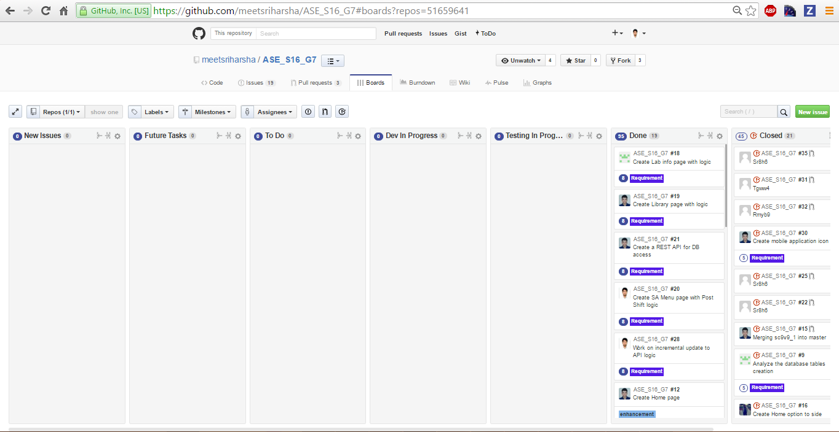

**Fig: ZenHub Board showing the project plan and current tasks.**

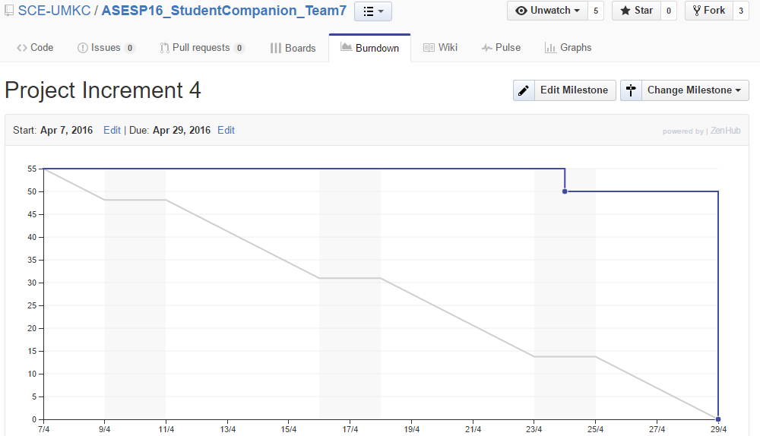

**Fig : Burndown chart for Increment 4**

**Agile website link:**

[https://github.com/SCE-UMKC/ASESP16\_StudentCompanion\_Team7#boards?repos=51659641](https://github.com/SCE-UMKC/ASESP16_StudentCompanion_Team7%23boards?repos=51659641)

**Source Code GitHub URL:** <https://github.com/SCE-UMKC/ASESP16_StudentCompanion_Team7>

**Presentation URL:** <https://github.com/SCE-UMKC/ASESP16_StudentCompanion_Team7/blob/master/Documentation/StudentCompanionBriefPPT_Group_7.pptx>

**YouTube Application Demo Video URL:** <https://www.youtube.com/watch?v=v6NcbSS8hcQ>

# Final Project Evaluation:

We’ve taken all the precautions to make sure that our project satisfies every possible outcome of the original requirement specifications. We’ve analyzed various application user interface patterns before we commit to the current one. We considered several factors such as application run environment, end users etc., to decide the application design pattern. Agile process helped us in exchanging the information, knowledge and project status updates effectively and immediately. We inherited several aspects of agile methodology in our project management processes. One of them is weekly team meetings on project status, issues and future work. This helped us in quick decision taking for the tasks.

I’ve faced some difficulty in my team as some team members are not completely familiar with the Ionic framework concepts. To overcome this, we’ve planned our work ahead of our task deadlines and were successful in completing them. We’ve also faced the “Billing” problem from Amazon Web Services as the “free” tier services are not really free. There are some limitations on the free tier like “one month free” or “2 million request hits free” etc., It should have been highlighted earlier in our tutorial classes.

If this was a real world project, I would have arranged internal team meetings every week. Also, I will arrange meetings with the clients to explain the tasks done till date and to take input suggestions from them. As the semester course was started with android basics and the important technical content (ionic framework, angularJS) was started at the end of the semester, our first two increments really don’t have much progress. This could be resolved by changing the course work flow. Other than that, all the remaining course and project schedules were perfect.

Student Companion

Project Plan and First Iteration Report

COMP-SCI 5551 Advanced Software Engineering

# Introduction

This document is intended to provide an overall description of the project named “Student Companion” in detail. The project schedule and the plan of action is also discussed. The proposal document will give an insight on the project. The outcome of the first increment is the high and low level design of the application.

# Project Goal and Objectives

The goal of this project is to provide various functionalities that a student uses regularly such as updating the profile, checking for computer lab availability, library study room reservation etc. The student details will already present in the database. The student has to login before he uses these functionalities. Main objectives of this application are:

* To reduce the student’s stress and to save the student’s time by providing the latest availability of the computer labs.
* To develop an application that helps the students in taking the decision on to which laboratory the students have to go.
* To secure the information by providing a login form to the end user.
* To provide a tool with which the students will be able to reserve the library study rooms.
* To ensure that the student will never miss his schedules by setting reminders.
* To enable the Student Assistants to view their shifts, post and take substitutions.
* To provide the students with the option to update their address or mobile phone number etc.

# Project Background and Related Work

Some functionalities of this application are already exist. We are creating a new android application which integrates (mash up) all the available and new functionalities under one hood, thus making the application a viable one. Some functionalities will be developed by importing the existing APIs into our application like Google Calendar API, Google Maps API etc. We are inspired by the problems that the Students are currently facing in reserving the study rooms, problems related to their working shifts and we came up with a solution which can resolve the existing challenges.

**Significance:**

The major significance of the application lies in mashing up of all the useful services under one system. This will save the student’s time and increases the productivity. The application will prevent the fraudulent usage by restricting the resources access to only the students who successfully logged in to the system. As of now, the student assistants has to go through a lengthy process in order to post or take shifts. The proposed application will make it easier for the student to perform such tasks by providing on-the-go support.

# Project Plan

The proposed project plan is outlined the by the screenshot from the ZenHub tool. The project is divided into four milestones. Each iteration has several states namely future tasks, new issues, to do, development in progress, testing in progress, done and closed.



Fig. 1 ZenHub Board showing the project plan and current tasks.

**Milestone 1:**

This milestone mainly deals with the designing the system for the implementation phase. The tasks of this phase mainly focuses on the UML diagram and collecting the necessary requirements details for the realization and development of the application. The results of this milestone contains the mockup screens of the application and the related class, sequence and state chart diagrams.

# First Increment Report

This document contains the report of first increment of work done on the Student Companion application. This document emphasizes the pictorial representation of the application using different implementations to get an insight on the internal system. We’re using the HTML5, CSS and Angular JS for the front end user interface creation.

First increment mainly involves in designing the application. We’ve created the class diagrams and sequence diagrams which depicts the workflow and the module relationships of the application. We’ve generated the application blueprint using the wireframes.

**Class diagram for the high level design of the application:**

**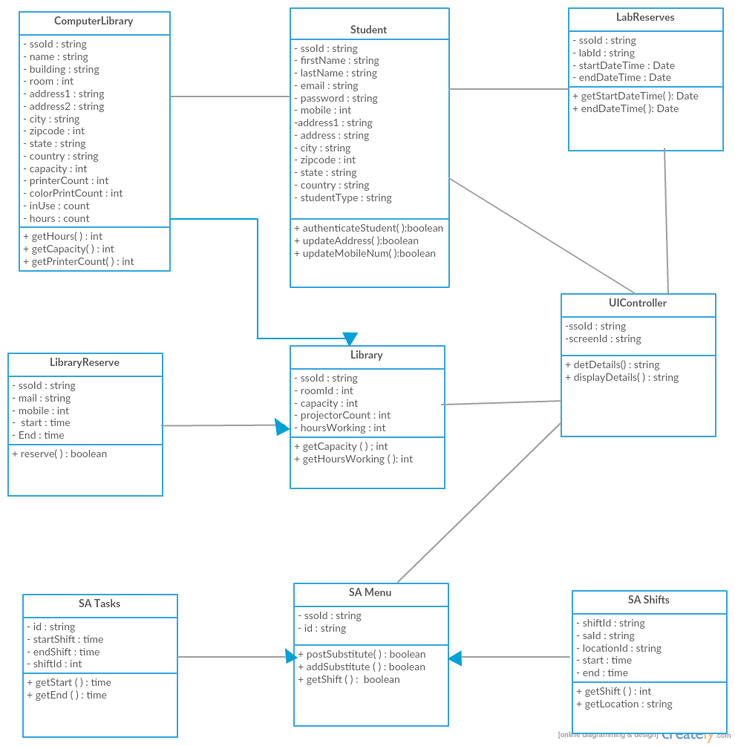**

Fig. 2 demonstrates a class diagram of high level design of application

**Sequence diagrams for the high level design of the application:**

**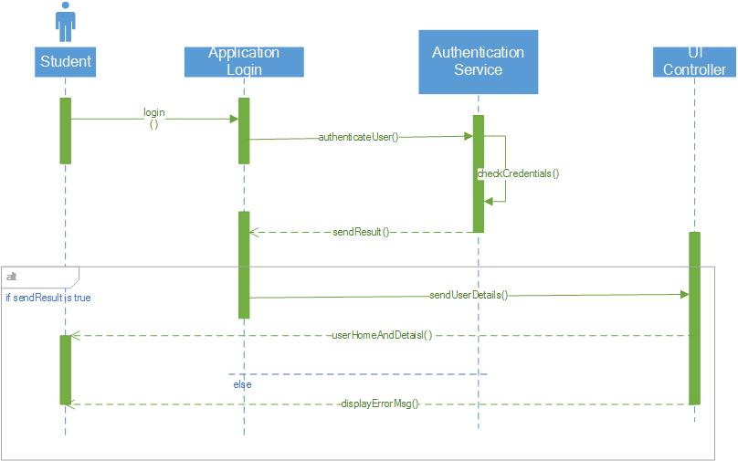**

Fig. 3 Sequence diagram for student login activity

**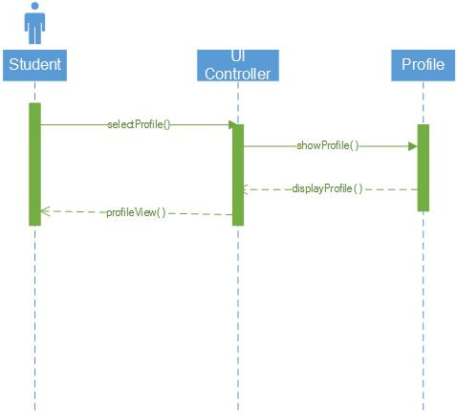**

Fig. 4 Sequence diagram shows the control flow for “view user profile” task

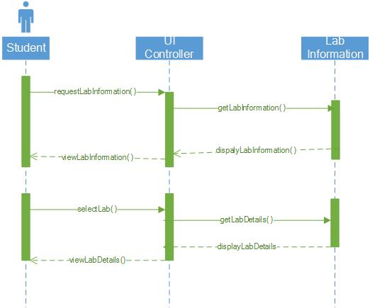

Fig. 5 Sequence diagram for “View lab information” activity

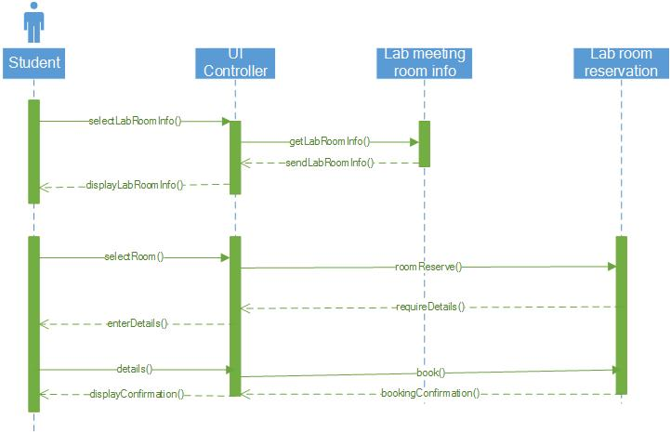

Fig. 6 Sequence diagram for reserving library study room activity

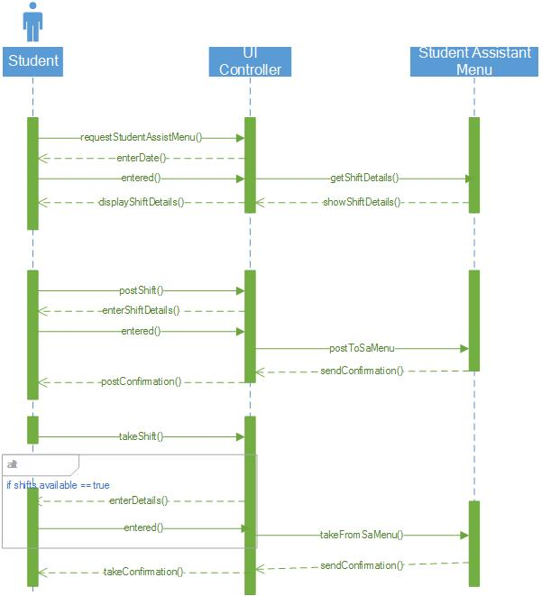

Fig. 7 Sequence diagram for student assistant activities like post or take shifts.

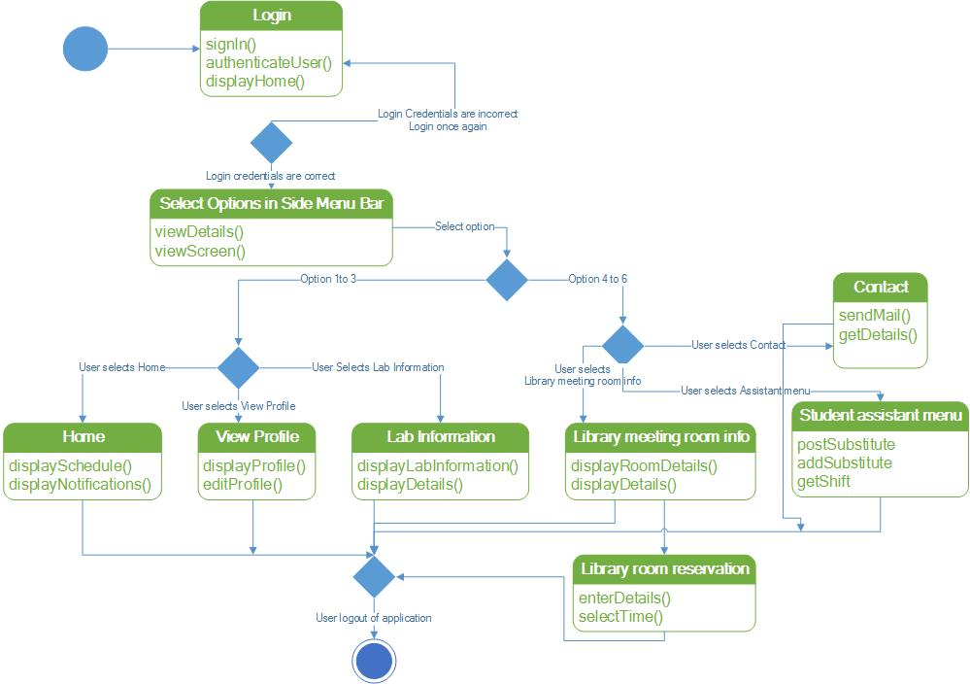

Fig. 8 State chart diagram for the application modules.

## Wireframes of the application

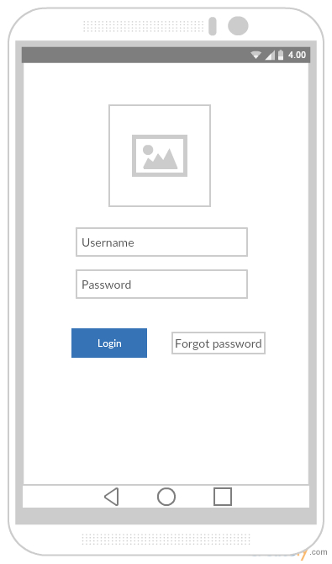

Fig. 9 Login screen

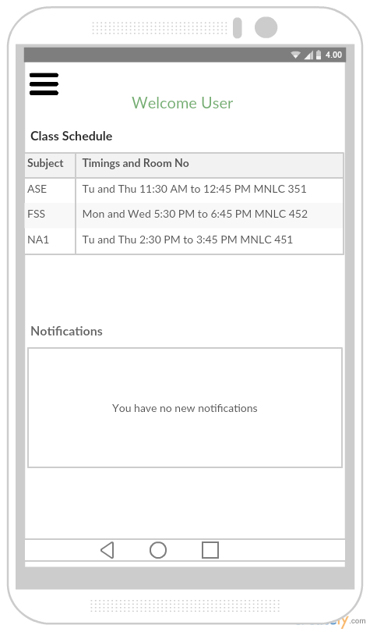

Fig. 10 Main Home page

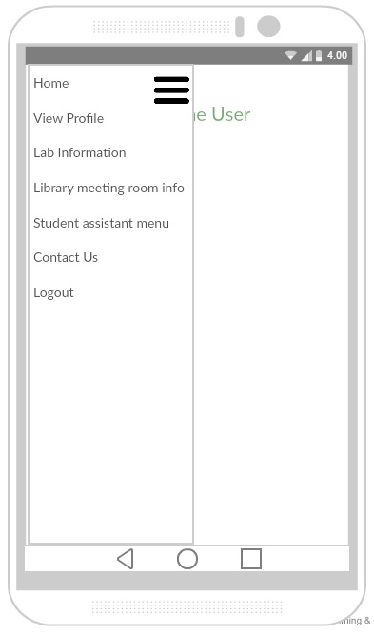

Fig. 11 Side menu bar

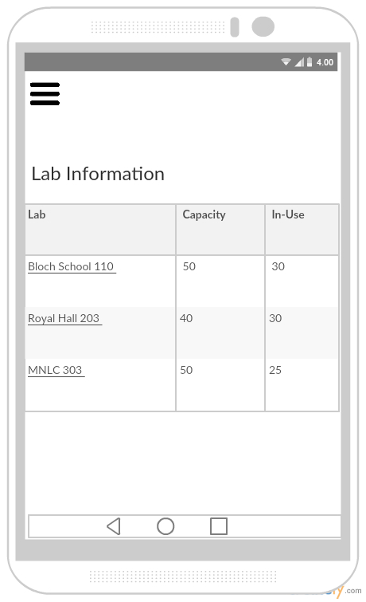

Fig. 12 Computer Labs information page

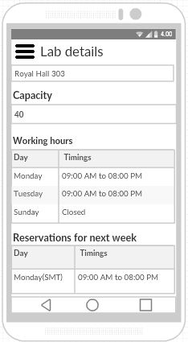

Fig. 13 Detailed information of a computer lab

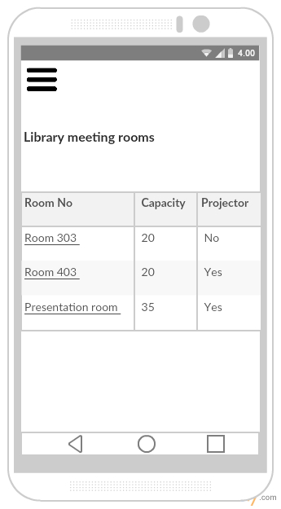

Fig. 14 Library study room information

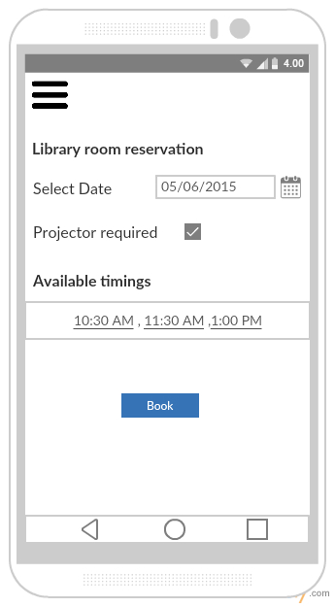

Fig. 15 Library room reservation page

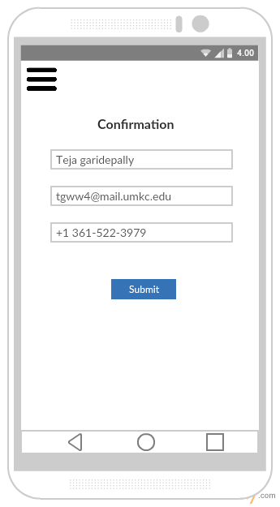

Fig. 16 Library room reservation form

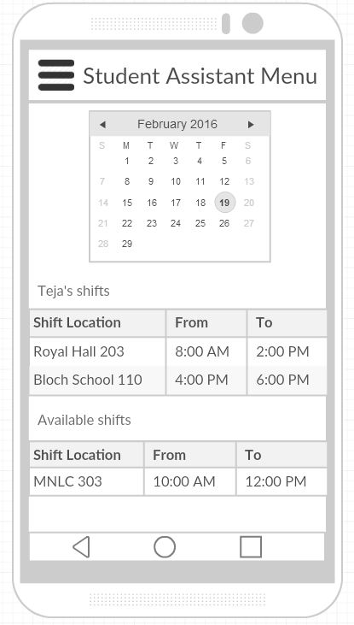

Fig. 17 Student Assistant menu page

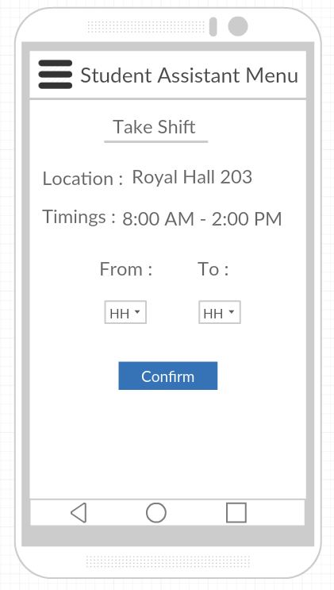

Fig. 18 Taking a Student Assistant shift

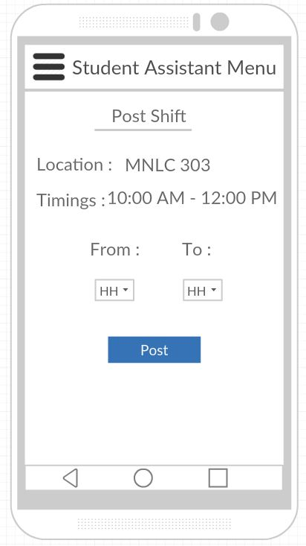

Fig. 19 Posting a Student Assistant shift

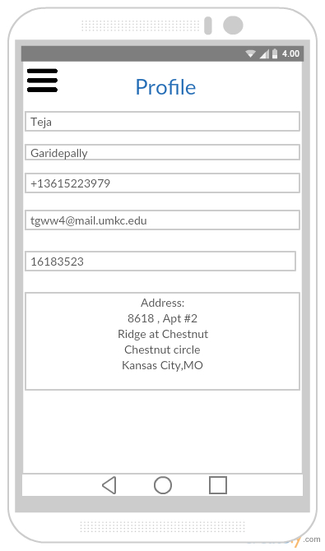

Fig. 20 Student profile page

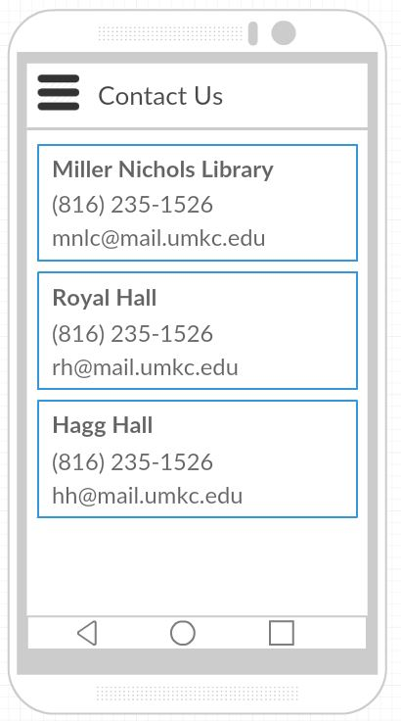

Fig. 21 Contact Us information page

# Project Management

## Work Completed

In detailed analysis of the system, environment and technical requirements for the application development. Project proposal documentation, Project tasks created in ZenHub and assigned the tasks to team members. Created the Project increment 1 document. All team members are involved in this task. Total time taken is 30 hours per person. Contributions: Harsha 30%, Teja 25%, Raj 25%, Suhas 20%.

## Work To Be Completed

We need to work on login page creation (both UI and logic) and the backend database tables creation. We would like to use mongo db as our database server. Raj Kiran and Harsha will work on login page creation. Teja and Suhas will work on creation of sample database tables. Projected person participation: Harsha 25%, Teja 25%, Raj 25%, Suhas 25%.

Student Companion

Second Iteration Report

COMP-SCI 5551 Advanced Software Engineering

# Introduction

This document is intended to provide an overall description of the project named “Student Companion” in detail. The project schedule and the plan of action is also discussed. The proposal document will give an insight on the project. The outcome of the second increment is the login page validation, database creation, home page creation and side menu creation.

# Project Goal and Objectives

The goal of this project is to provide various functionalities that a student uses regularly such as updating the profile, checking for computer lab availability, library study room reservation etc. The student details will already present in the database. The student has to login before he uses these functionalities. Main objectives of this application are:

* To reduce the student’s stress and to save the student’s time by providing the latest availability of the computer labs.
* To develop an application that helps the students in taking the decision on to which laboratory the students have to go.
* To secure the information by providing a login form to the end user.
* To provide a tool with which the students will be able to reserve the library study rooms.
* To ensure that the student will never miss his schedules by setting reminders.
* To enable the Student Assistants to view their shifts, post and take substitutions.
* To provide the students with the option to update their address or mobile phone number etc.

# Project Background and Related Work

Some functionalities of this application are already exist. We are creating a new android application which integrates (mash up) all the available and new functionalities under one hood, thus making the application a viable one. Some functionalities will be developed by importing the existing APIs into our application like Google Calendar API, Google Maps API etc. We are inspired by the problems that the Students are currently facing in reserving the study rooms, problems related to their working shifts and we came up with a solution which can resolve the existing challenges.

**Significance:**

The major significance of the application lies in mashing up of all the useful services under one system. This will save the student’s time and increases the productivity. The application will prevent the fraudulent usage by restricting the resources access to only the students who successfully logged in to the system. As of now, the student assistants has to go through a lengthy process in order to post or take shifts. The proposed application will make it easier for the student to perform such tasks by providing on-the-go support.

# Work flow

The first workflow of the application is that of the designing the User Interface for the system. Our application goal is to provide instant access to the user regarding lab availability and library room availability. So, for this we are developing an mobile application. We are using ionic framework so that we can develop hybrid application.

Second, we have created the login page and database using MongoLab and we have successfully authenticated the user based on his details which are stored in database in mongodb.

The third workflow deals with the creating a mongodb database to store and retrieve the user profile and information about IS labs, library study rooms etc. The work flow of the each and every feature of the application is explained through sequence diagrams and state chart diagram presented in the first increment report.

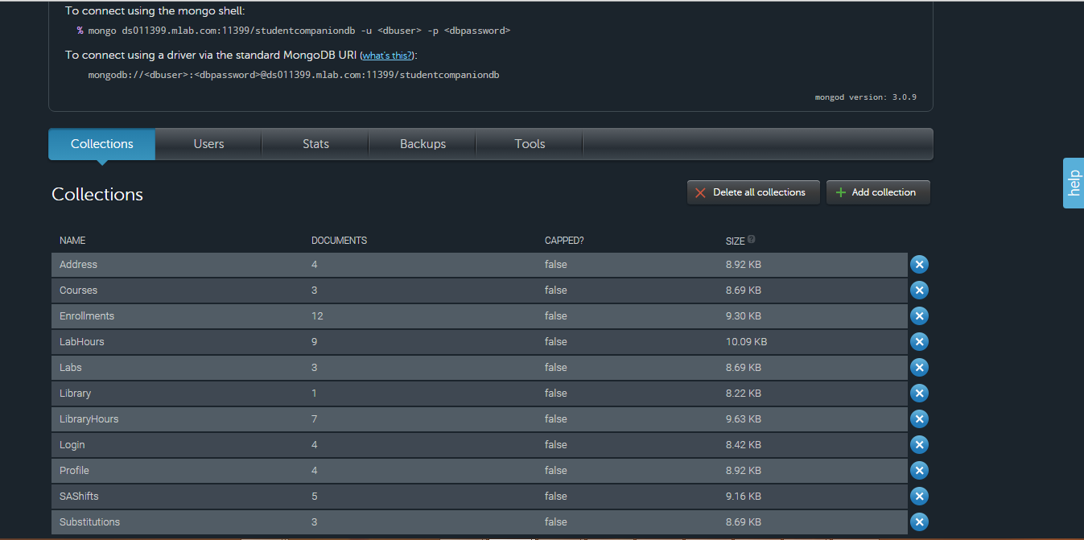

# Technological and architecture requirements

In the application system need to interact with the database for retrieving the data to do this interaction between the system and database is done through REST technology. We use CRUD API calls of the REST for accessing the database.

Ionic framework, it is a powerful SDK used to develop hybrid applications using web technologies like HTML, CSS and JavaScript. It is also a core in providing better UI to the user.

The architectural requirement aims at the development of flexible architecture for the better interaction between the system and the database.

# Existing Services/API

We have so far used the MongoDB in our application. MongoDB is a cross-platform document-oriented database and it is a NoSQL database, MongoDB avoids the traditional table-based relational database structure in favor of JSON-like documents with dynamic schemas making the integration of data in certain types of applications easier and faster.

We have used mongoDB to store the information of the users and data about the IS labs, library study rooms, student assistant information etc. Using REST API calls data is retrieved from the database and displayed to the user.

mLab is a fully managed cloud database service that hosts and provide featuring automated provisioning and scaling of MongoDB databases. Data can be accessed from mongoDB using two ways. Fist, by using the DATA APT URL in which it contains database name, collection name and API key.

Example URL:

**[https://api.mongolab.com/api/1/databases/studentcorner/collections//Ase\_project/'](https://api.mongolab.com/api/1/databases/studentcorner/collections//Ase_project/' + id + '?apiKey=Q_u73BV4oOdMGpnu3WFGmJ8YH_HDHO)** [+ id +](https://api.mongolab.com/api/1/databases/studentcorner/collections//Ase_project/' + id + '?apiKey=Q_u73BV4oOdMGpnu3WFGmJ8YH_HDHO) **['?apiKey=Q\_u73BV4oOdMGpnu3WFGmJ8YH\_HDHO](https://api.mongolab.com/api/1/databases/studentcorner/collections//Ase_project/' + id + '?apiKey=Q_u73BV4oOdMGpnu3WFGmJ8YH_HDHO)**

Second, accessing the mongoDB using a driver to connect the database. An example driver:

mongodb://<dbuser>:<dbpassword>@ds011399.mlab.com:11399/studentcompaniondb

# Architecture Diagram

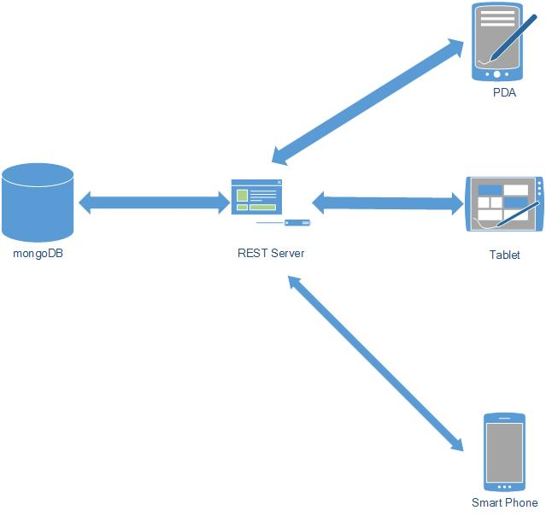

Fig 1: Architecture Diagram for StudentCompanion

The architecture diagram for our application shows that it is 3-tier architecture. Application which deployed in smart phones, PDA’s and Tablet uses the REST services for interacting with the database for storing and retrieval of required information from the mongoDB.

# Project plan

The proposed project plan is outlined the by the screenshot from the ZenHub tool. The project is divided into four milestones. Each iteration has several states namely future tasks, new issues, to do, development in progress, testing in progress, done and closed.



Fig. 2 ZenHub Board showing the project plan and current tasks.

**Milestone 2:**

This milestone mainly deals with the designing the system for the implementation phase. The tasks of this phase mainly focuses three tasks.

First, the development of basic skeleton which gives pleasant UI to the user.

Second, development of login page and authentication of user using his/her credentials which are stored in the mongoDB.

Third, creation of database using mongoDB , populating the database and accessing the database using monoDB API.

The results of this milestone contains the screenshots of the application and the related class, sequence and state chart diagrams.

# Second Increment Report

This document contains the report of second increment of work done on the Student Companion application. This document emphasizes the initial implementation of the application using different web technologies such as CSS,HTML5,JavaScript and mongoDB. We’re using the HTML5, CSS and Angular JS for the front end user interface creation.

We have created our database in mongoDB and the interaction between the system and database is through REST API calls. We have used mongoDB API for data accessing by using API key authentication.

We have created the login page and the user login is done by authenticating the user by checking the credentials with that are stored in database. We have also checked the work so far by deploying the application in the mobile and manual testing is done.

The detail development in second increment include the login page, database creation using mongoDB and accessing database using REST API calls. We are going to work on the other features in the side menu bar in upcoming increment.

**Class diagram for the high level design of the application:**

****

Fig. 2 demonstrates a class diagram of high level design of application

**Sequence diagrams for the high level design of the application:**

****

Fig. 3 Sequence diagram for student login activity

****

Fig. 4 Sequence diagram shows the control flow for “view user profile” task



Fig. 5 Sequence diagram for “View lab information” activity



Fig. 6 Sequence diagram for reserving library study room activity



Fig. 7 Sequence diagram for student assistant activities like post or take shifts.



Fig. 8 State chart diagram for the application modules.

## Wireframes of the application



Fig. 9 Login screen



Fig. 10 Main Home page



Fig. 11 Side menu bar



Fig. 12 Computer Labs information page



Fig. 13 Detailed information of a computer lab



Fig. 14 Library study room information



Fig. 15 Library room reservation page



Fig. 16 Library room reservation form



Fig. 17 Student Assistant menu page



Fig. 18 Taking a Student Assistant shift



Fig. 19 Posting a Student Assistant shift



Fig. 20 Student profile page



Fig. 21 Contact Us information page

**User Stories:**

* As a User, I can see the UI of StudentCompanion App.
* As a user, I can see the Login Screen.
* As a user, I can enter my Details and Login to the App.
* As a user, I can see the Side menu bar on Home Page with side menu options like Profile, Lab Information, Reserve Study Room, and SA Menu.
* As a User, I can see my Profile.
* As a User, I can see the Lab Information of specified lab.
* As a User, I can Reserve Study Room.
* As a User, I can choose the SA Menu option
* As a User, I can utilize the options in SA Menu.

As a user, I can Sign-out from the Application.

# Deployment

Deployment of application to Mobile phone.

Screen Shots:

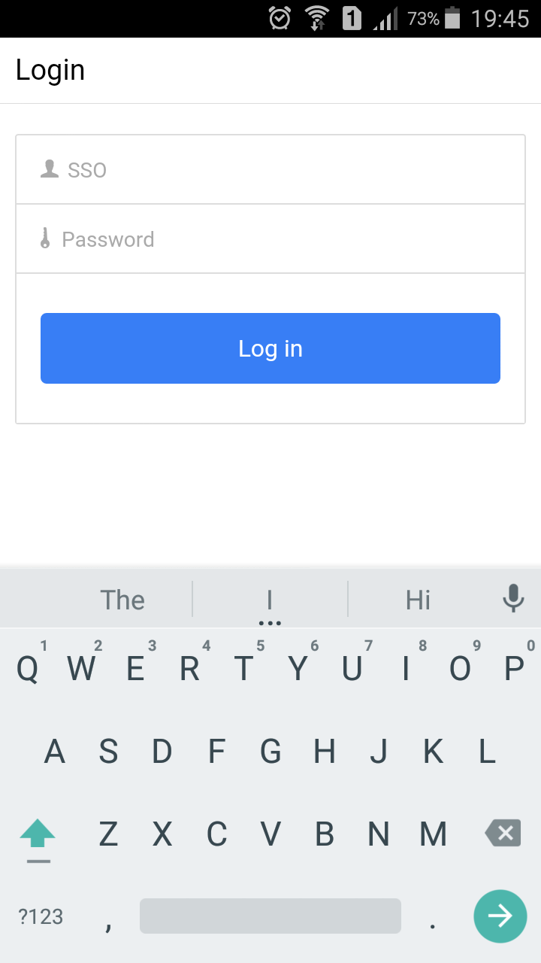

Fig: Login Screen

# C:\Users\RajKiranReddyM\Desktop\aseprojectincrement2appscreenshots\Testing.png

Fig : Login Fail message screen

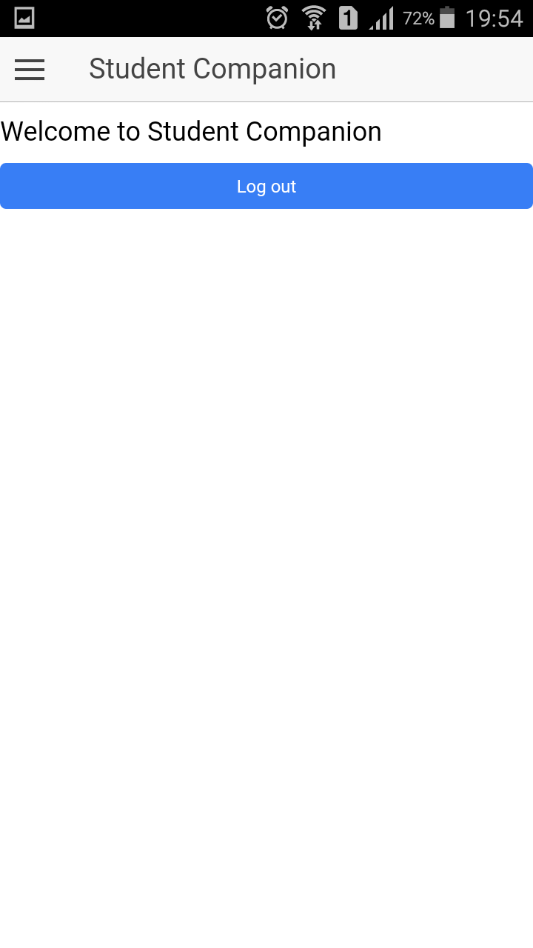

Fig: Home Screen

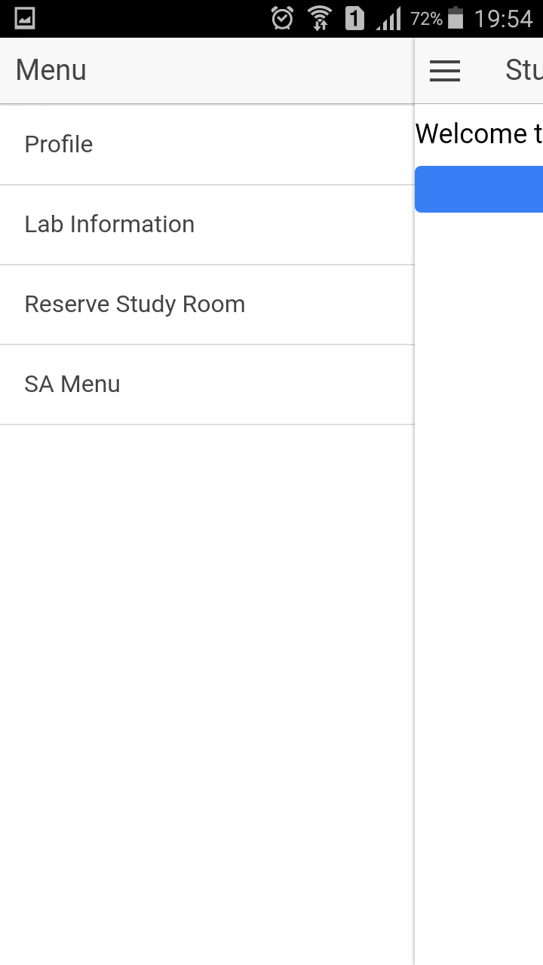

Fig: Side Menu

**Web Application:**

**Screenshots:**

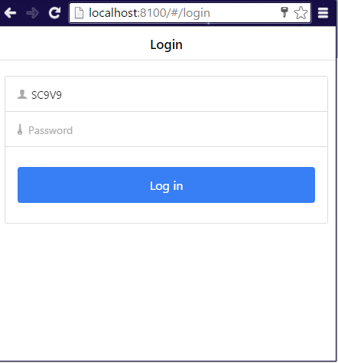

Fig: Login

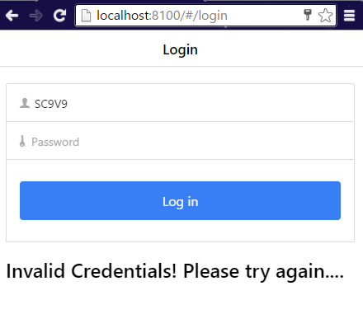

Fig: Login fail message screenshot

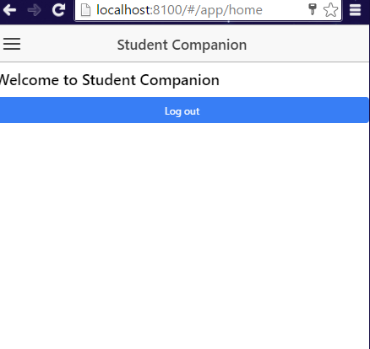

Fig: Home

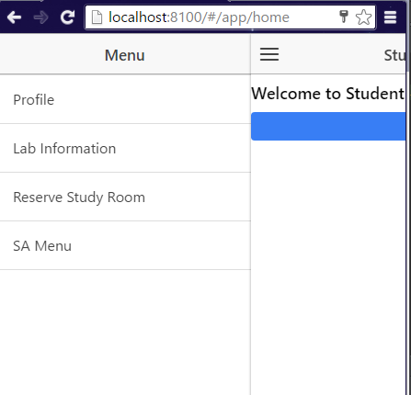

Fig: Side Menu

**Project URL:**

<https://github.com/meetsriharsha/ASE_S16_G7/tree/master/SourceCode/Increment2/StudentCompanion>

**Second Increment Document URL:**

<https://github.com/meetsriharsha/ASE_S16_G7/tree/master/Documentation>

# Project Management

## Work Completed

In detailed analysis of the system, environment and technical requirements for the application development. Project proposal documentation, Project tasks created in ZenHub and assigned the tasks to team members. Created the Project increment 1 document. All team members are involved in this task. Total time taken is 50 hours per person. Contributions: Harsha27.5%, Teja 27.5%, Raj 27.5%, Suhas 17.5%.

## Work To Be Completed

We need to work on remaining side-menu pages creation (both UI and logic) and we need to work on UI tweaking. We’re planning to concentrate on controller logic of the application. Raj Kiran and Harsha will work on Profile and Home page creation. Teja and Suhas will work on computer lab information and library information pages. We will also work on calendar inclusion for library room reservation. Projected person participation: Harsha 25%, Teja 25%, Raj 25%, Suhas 25%.

Student Companion

Third Iteration Report

COMP-SCI 5551 Advanced Software Engineering

# Introduction

This document is intended to provide an overall description of the project named “Student Companion” in detail. The project schedule and the plan of action is also discussed. The proposal document will give an insight on the project. The outcome of the second increment is the login page validation, database creation, home page creation and side menu creation.

# Project Goal and Objectives

The goal of this project is to provide various functionalities that a student uses regularly such as updating the profile, checking for computer lab availability, library study room reservation etc. The student details will already present in the database. The student has to login before he uses these functionalities. Main objectives of this application are:

* To reduce the student’s stress and to save the student’s time by providing the latest availability of the computer labs.
* To develop an application that helps the students in taking the decision on to which laboratory the students have to go.
* To secure the information by providing a login form to the end user.
* To provide a tool with which the students will be able to reserve the library study rooms.
* To ensure that the student will never miss his schedules by setting reminders.
* To enable the Student Assistants to view their shifts, post and take substitutions.
* To provide the students with the option to update their address or mobile phone number etc.

# Project Background and Related Work

Some functionalities of this application are already exist. We are creating a new android application which integrates (mash up) all the available and new functionalities under one hood, thus making the application a viable one. Some functionalities will be developed by importing the existing APIs into our application like Google Calendar API, Google Maps API etc. We are inspired by the problems that the Students are currently facing in reserving the study rooms, problems related to their working shifts and we came up with a solution which can resolve the existing challenges.

**Significance:**

The major significance of the application lies in mashing up of all the useful services under one system. This will save the student’s time and increases the productivity. The application will prevent the fraudulent usage by restricting the resources access to only the students who successfully logged in to the system. As of now, the student assistants has to go through a lengthy process in order to post or take shifts. The proposed application will make it easier for the student to perform such tasks by providing on-the-go support.

# Work flow

The first workflow of the application is that of the designing the User Interface for the system. Our application goal is to provide instant access to the user regarding lab availability and library room availability. So, for this we are developing an mobile application. We are using ionic framework so that we can develop hybrid application.

Second, we have created the login page and database using MongoLab and we have successfully authenticated the user based on his details which are stored in database in mongodb.

The third workflow deals with the creating a mongodb database to store and retrieve the user profile and information about IS labs, library study rooms etc. The work flow of the each and every feature of the application is explained through sequence diagrams and state chart diagram presented in the first increment report.



# Technological and architecture requirements

In the application system need to interact with the database for retrieving the data to do this interaction between the system and database is done through REST technology. We use CRUD API calls of the REST for accessing the database.

Ionic framework, it is a powerful SDK used to develop hybrid applications using web technologies like HTML, CSS and JavaScript. It is also a core in providing better UI to the user.

The architectural requirement aims at the development of flexible architecture for the better interaction between the system and the database.

# Existing Services/API

We have so far used the MongoDB in our application. MongoDB is a cross-platform document-oriented database and it is a NoSQL database, MongoDB avoids the traditional table-based relational database structure in favor of JSON-like documents with dynamic schemas making the integration of data in certain types of applications easier and faster.

We have used mongoDB to store the information of the users and data about the IS labs, library study rooms, student assistant information etc. Using REST API calls data is retrieved from the database and displayed to the user.

mLab is a fully managed cloud database service that hosts and provide featuring automated provisioning and scaling of MongoDB databases. Data can be accessed from mongoDB using two ways. Fist, by using the DATA APT URL in which it contains database name, collection name and API key.

Example URL: [**https://api.mongolab.com/api/1/databases/studentcorner/collections//Ase\_project/'** + id + **'?apiKey=Q\_u73BV4oOdMGpnu3WFGmJ8YH\_lxHDHO**](https://api.mongolab.com/api/1/databases/studentcorner/collections/Ase_project/'%20+%20id%20+%20'?apiKey=Q_u73BV4oOdMGpnu3WFGmJ8YH_lxHDHO)

Second, accessing the mongoDB using a driver to connect the database. An example driver:

mongodb://<dbuser>:<dbpassword>@ds011399.mlab.com:11399/studentcompaniondb

**REST Services:**

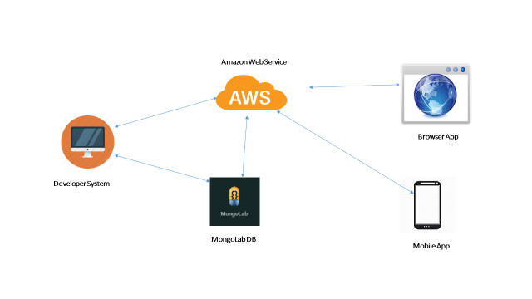

We have developed an API through which we perform the REST services for our application. As in the second increment we have developed database in the mongoLab and the data is fetched from the mongoLab through REST services.

We have used Amazon Web Services as a server to host our REST API. Our REST API will run in background and listen to port 9000.Our application send data request to the REST API hosted on Amazon EC2 cloud server. REST API will fetch the request data from mongoDB collections and perform the filtering of data according to the criteria and sends responds to the client application.

This enables us complex queries on the server instead on the client thereby increasing the performance of client application.

# Architecture Diagram



Fig 1: Architecture Diagram for StudentCompanion

The architecture diagram for our application shows that it is 3-tier architecture. Application which deployed in smart phones, PDA’s and Tablet uses the REST services for interacting with the database for storing and retrieval of required information from the mongoDB.

# Project plan

The proposed project plan is outlined the by the screenshot from the ZenHub tool. The project is divided into four milestones. Each iteration has several states namely future tasks, new issues, to do, development in progress, testing in progress, done and closed.



Fig. 2 ZenHub Board showing the project plan and current tasks.

**Milestone 3:**

This milestone mainly deals with the designing the end to end functionality of the system. The tasks of this phase mainly focuses six tasks.

First, the development of REST API which performs the communication between Client application and database.

Second, development of Profile page and display the profile of the user which is stored in the mongoDB.

Third, development of Lab Information page and display the Lab name, available work stations and systems which are in use in that lab.

Fourth, development of Reserve Study Room page and display the Library information, study rooms which are reserved by the user and available study rooms.

Fifth, development SA Menu page and display the SA Shifts of the user on a or after a particular date.

The results of this milestone contains the screenshots of the application and the related class, sequence and state chart diagrams.

# Third Increment Report

This document contains the report of third increment of work done on the Student Companion application. This document emphasizes the end to end implementation of the application using different technologies such as REST API, Amazon Web Services, Ionic framework and mongoDB. We’re using the HTML5, CSS ,Node.js, , ExpressJS and Angular JS for the end to end implementation.

We have created REST API which host on the Amazon Web Services through which communication between client application and database.

We have created the Profile, Lab Information, Reserve Study Room, SA Menu, Contact Us pages. We have also checked the work so far by deploying the application in the mobile and manual testing is done.

The detail development in third increment include the creation of REST API, Profile, Lab Information, Reserve Study Room, SA Menu, Contact Us pages. We are going to work enhancement of application, improving use interface, bug fixes and the remaining functionalities of the application.

**Class diagram for the high level design of the application:**

****

Fig. 2 demonstrates a class diagram of high level design of application

**Sequence diagrams for the high level design of the application:**

****

Fig. 3 Sequence diagram for student login activity

****

Fig. 4 Sequence diagram shows the control flow for “view user profile” task



Fig. 5 Sequence diagram for “View lab information” activity



Fig. 6 Sequence diagram for reserving library study room activity



Fig. 7 Sequence diagram for student assistant activities like post or take shifts.



Fig. 8 State chart diagram for the application modules.

## Wireframes of the application



Fig. 9 Login screen



Fig. 10 Main Home page



Fig. 11 Side menu bar



Fig. 12 Computer Labs information page



Fig. 13 Detailed information of a computer lab



Fig. 14 Library study room information



Fig. 15 Library room reservation page



Fig. 16 Library room reservation form



Fig. 17 Student Assistant menu page



Fig. 18 Taking a Student Assistant shift



Fig. 19 Posting a Student Assistant shift



Fig. 20 Student profile page



Fig. 21 Contact Us information page

**User Stories:**

* As a User, I can see the UI of StudentCompanion App.
* As a user, I can see the Login Screen.
* As a user, I can enter my Details and Login to the App.
* As a user, I can see the Side menu bar on Home Page with side menu options like Profile, Lab Information, Reserve Study Room, and SA Menu.
* As a User, I can see my Profile.
* As a User, I can see the Lab Information of specified lab.
* As a User, I can Reserve Study Room.
* As a User, I can choose the SA Menu option
* As a User, I can utilize the options in SA Menu.

As a user, I can Sign-out from the Application.

# Deployment

Deployment of application to Mobile phone.

Screen Shots:



Fig: Login Screen

# Testing

Fig: Login Failed

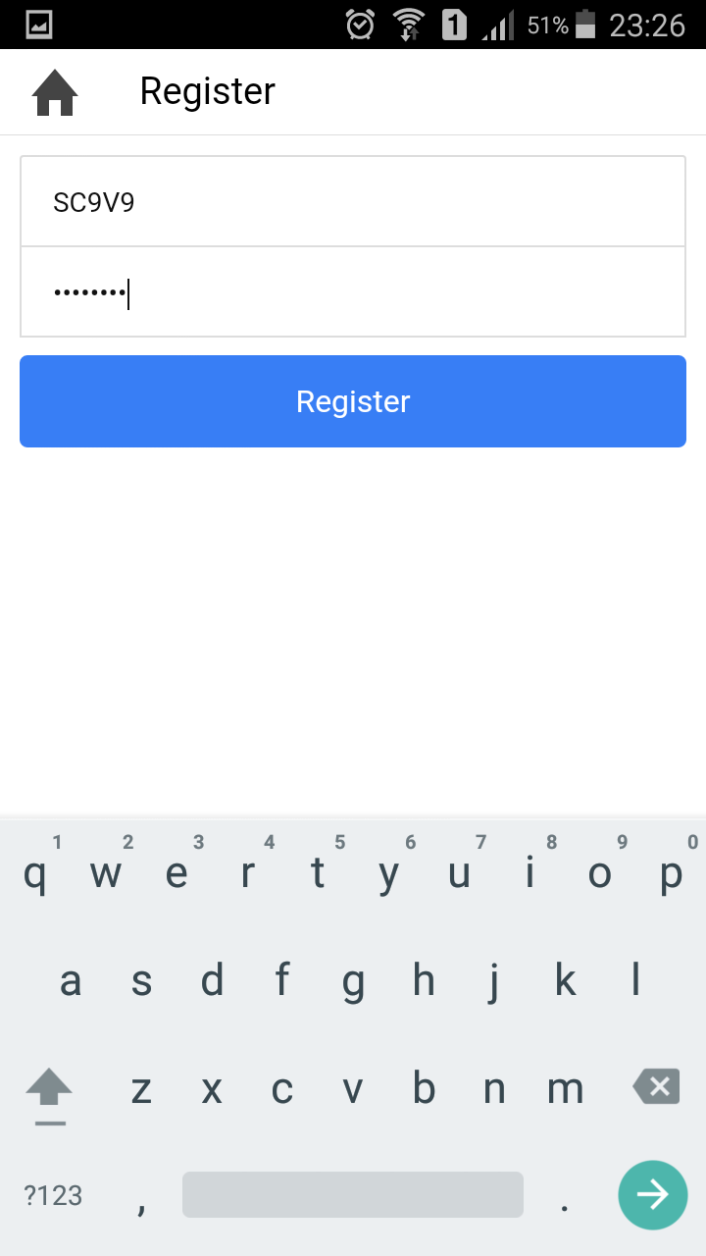

Fig: Register

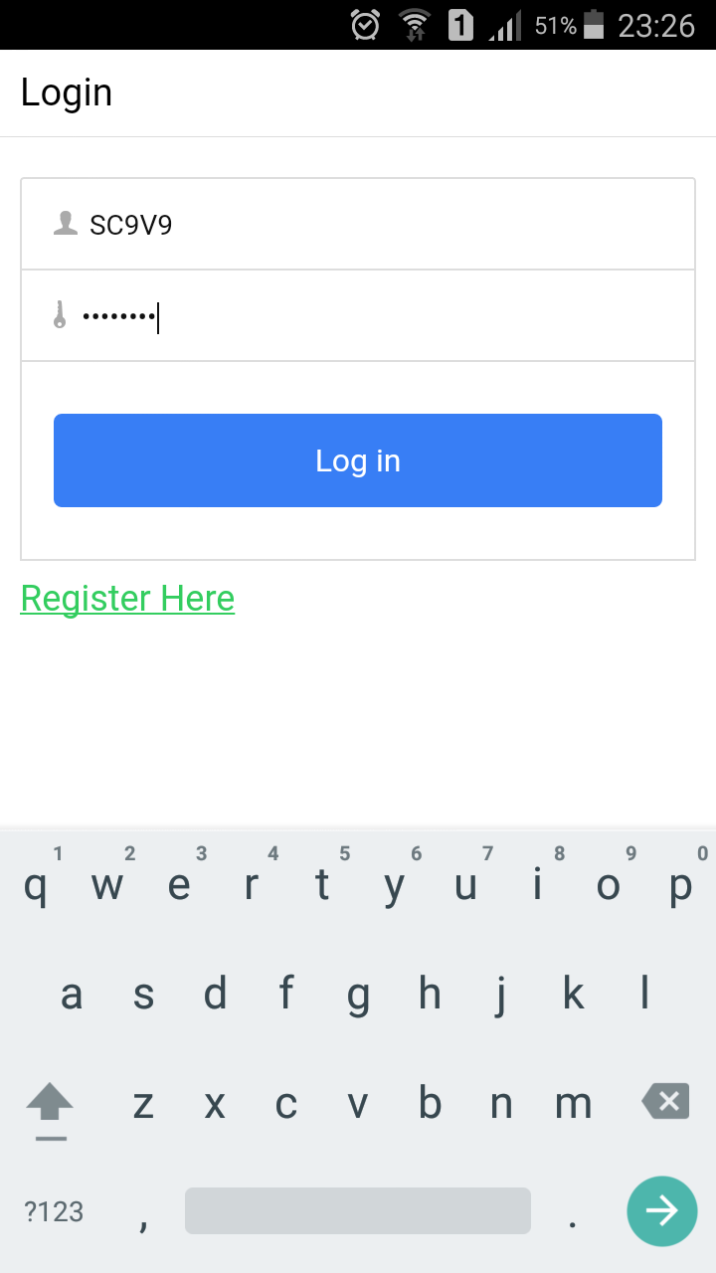

Fig: Login Success



Fig: Home Screen

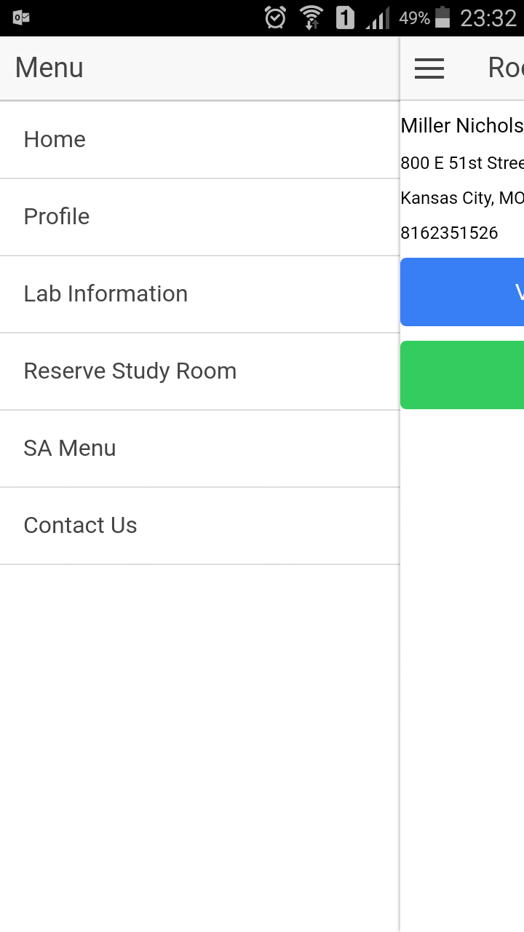

Fig: Side Menu

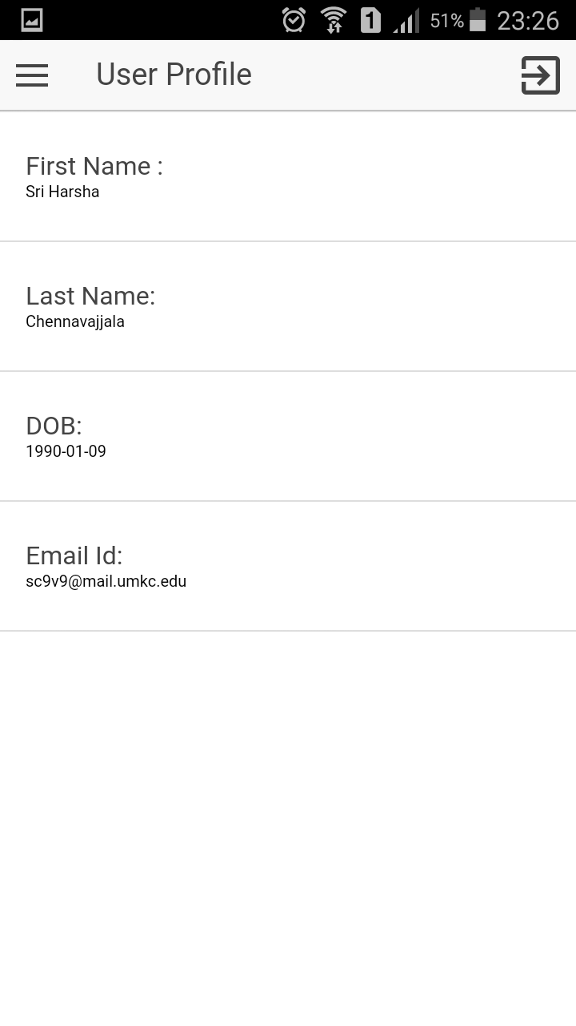

Fig Profile

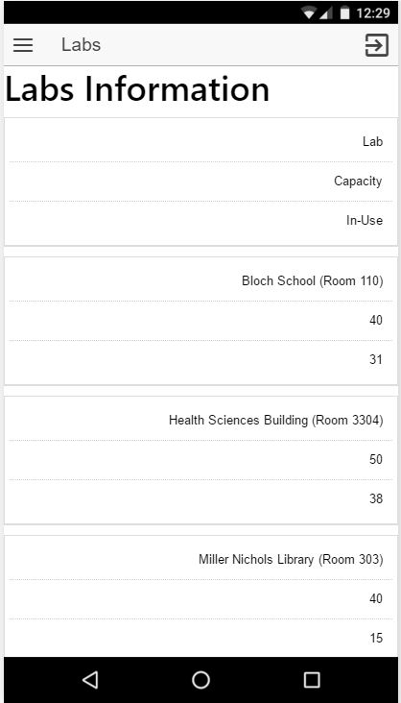

Fig:Labs

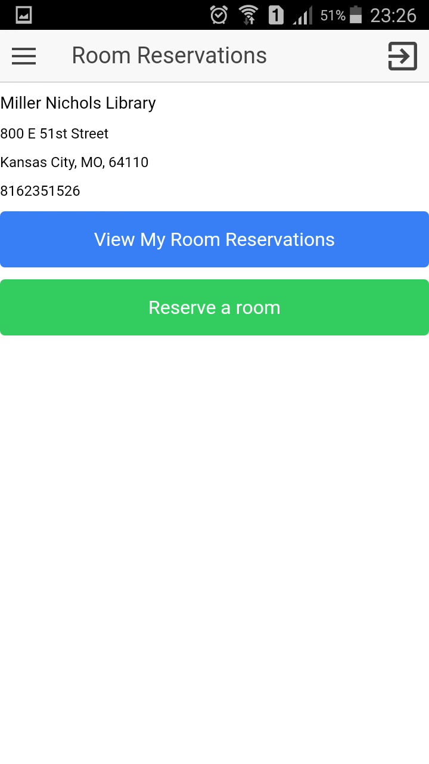

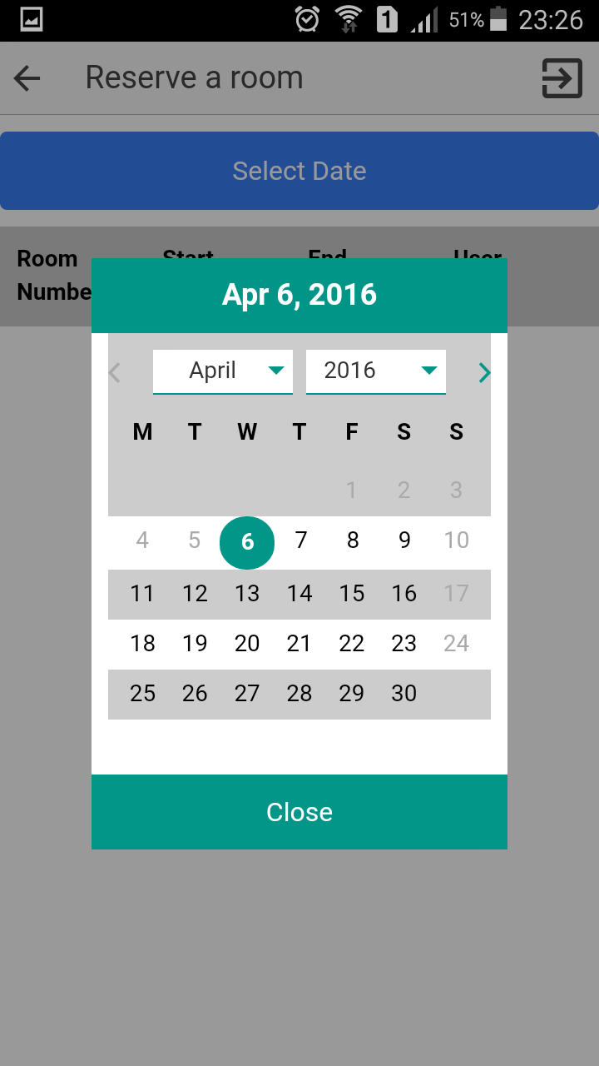

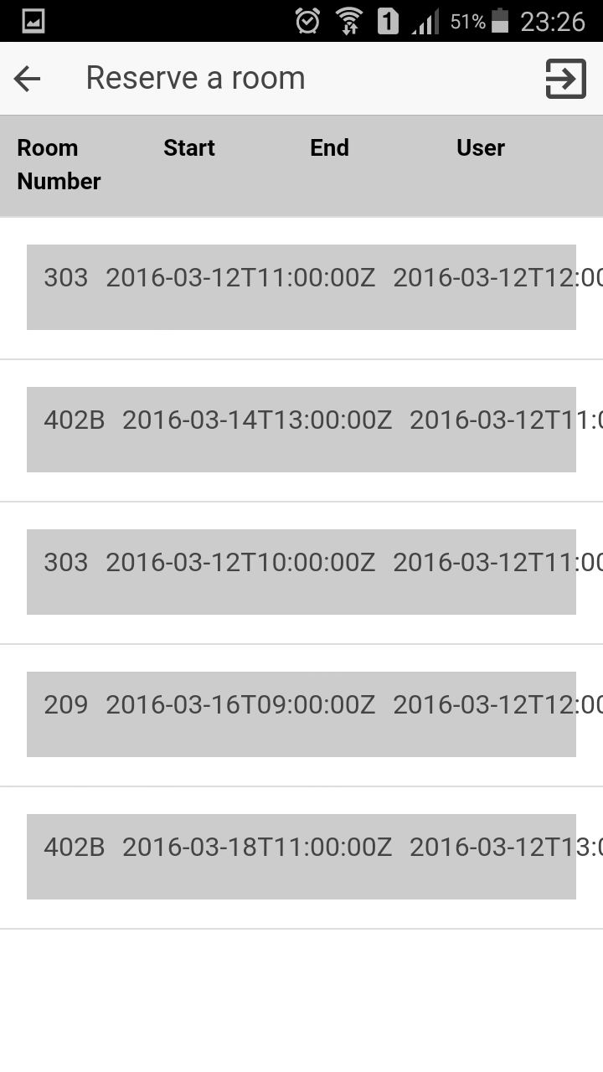

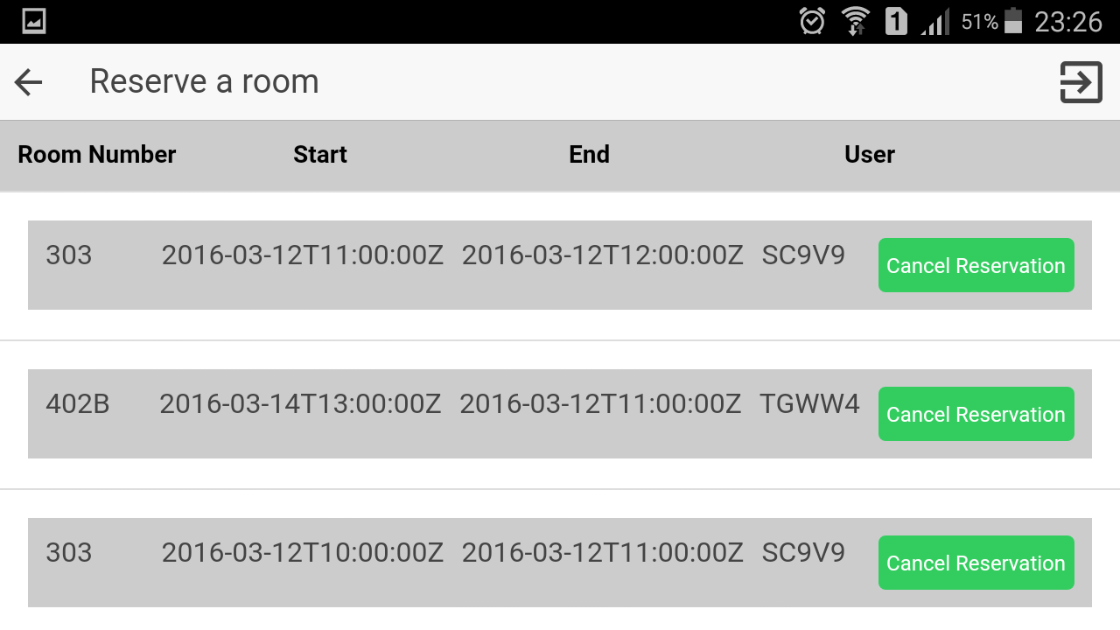

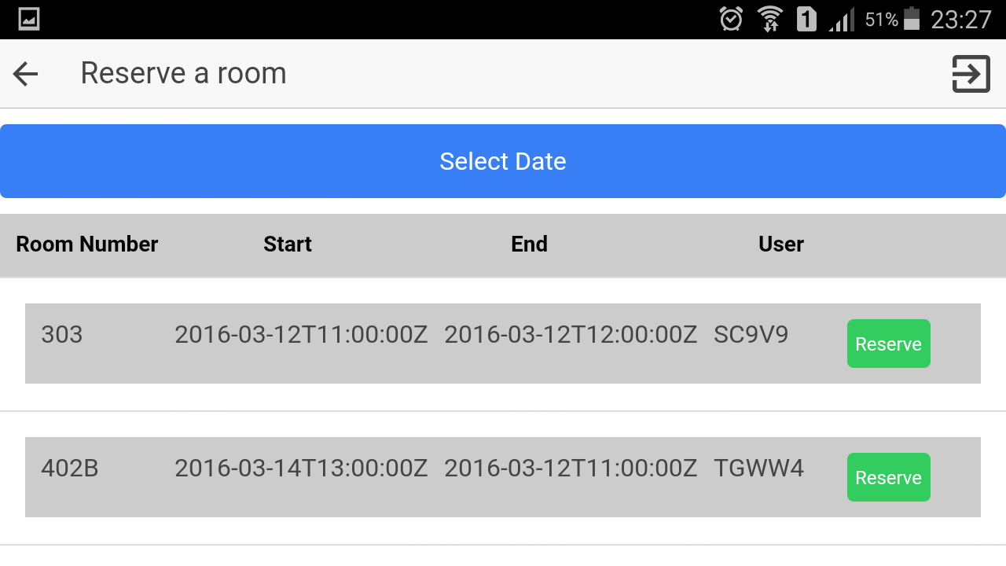

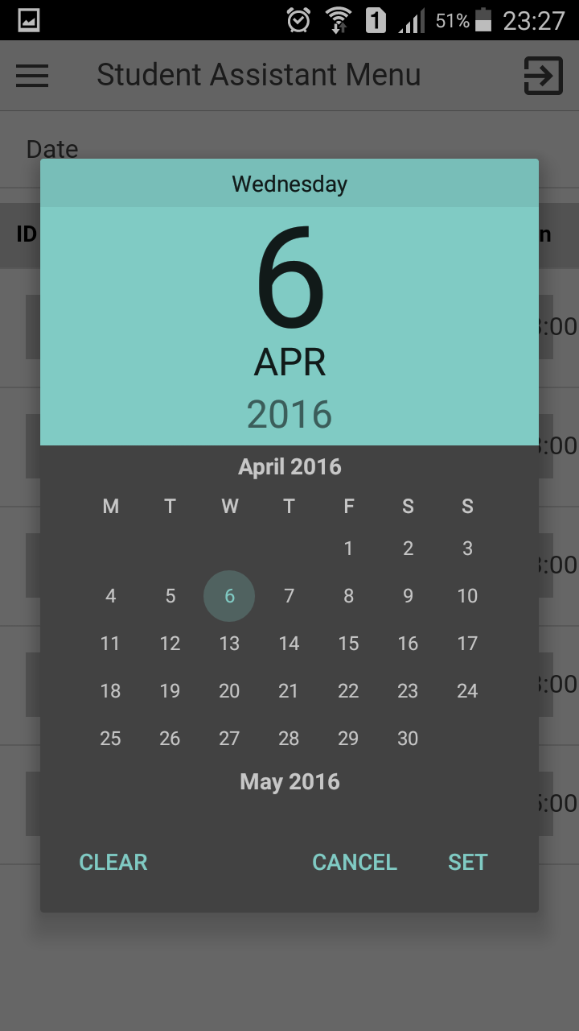

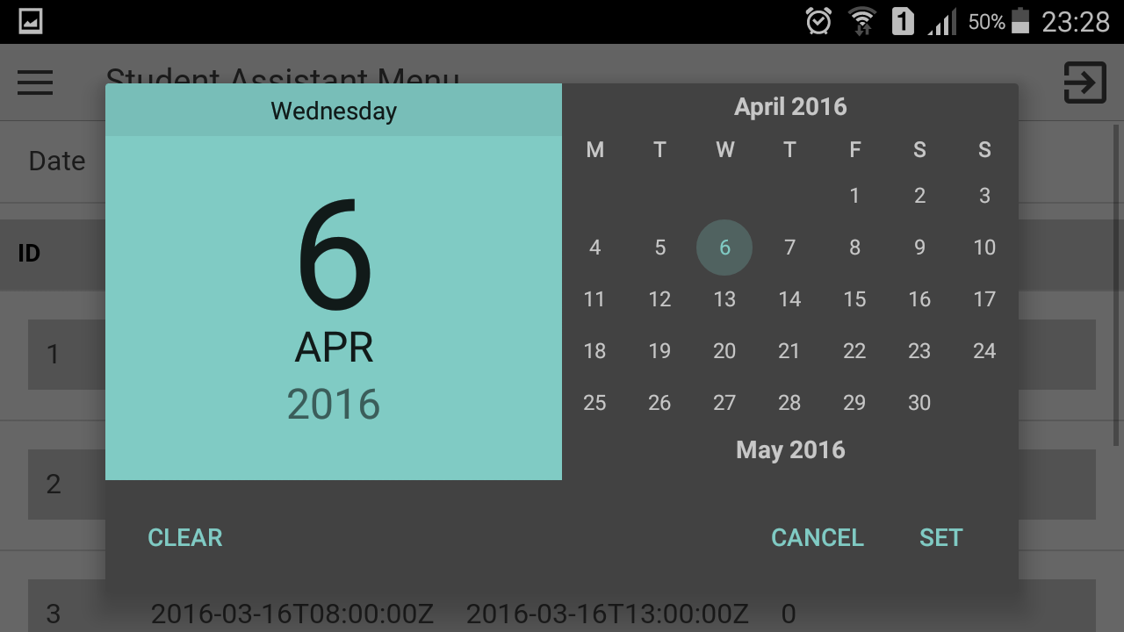

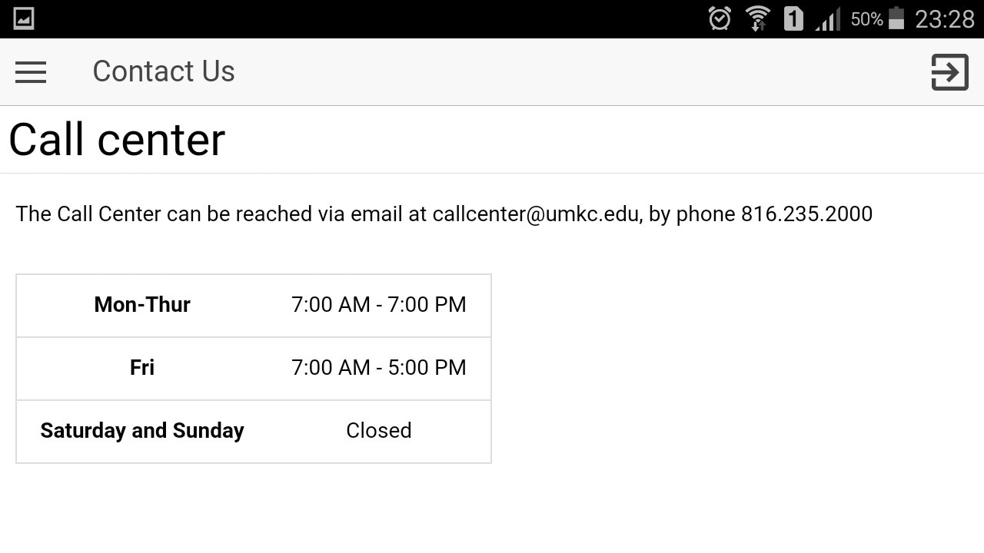

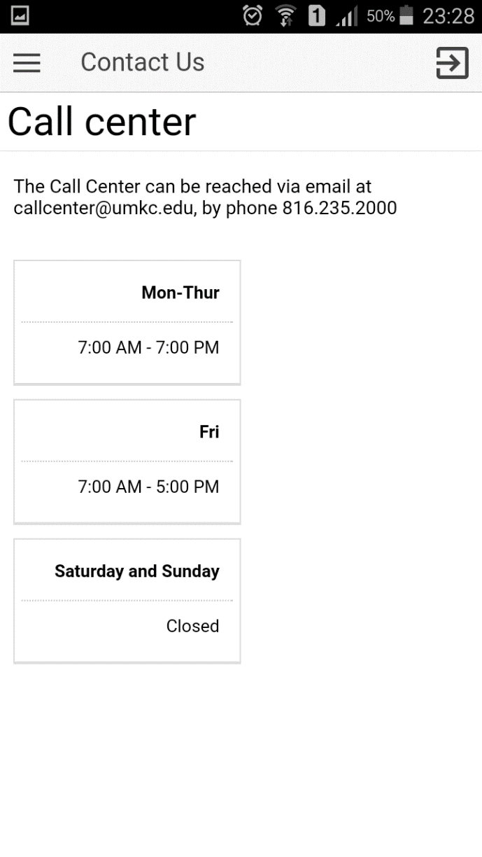

**Web Application:**

**Screenshots:**



Fig: Login



Fig: Login fail



Fig : Home



Fig: Side Menu

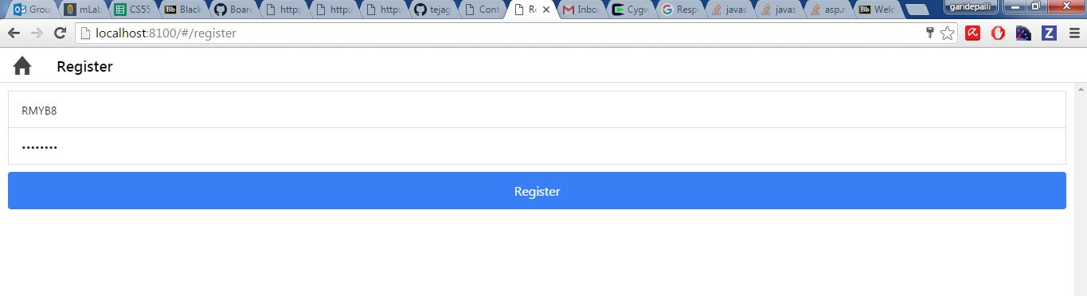

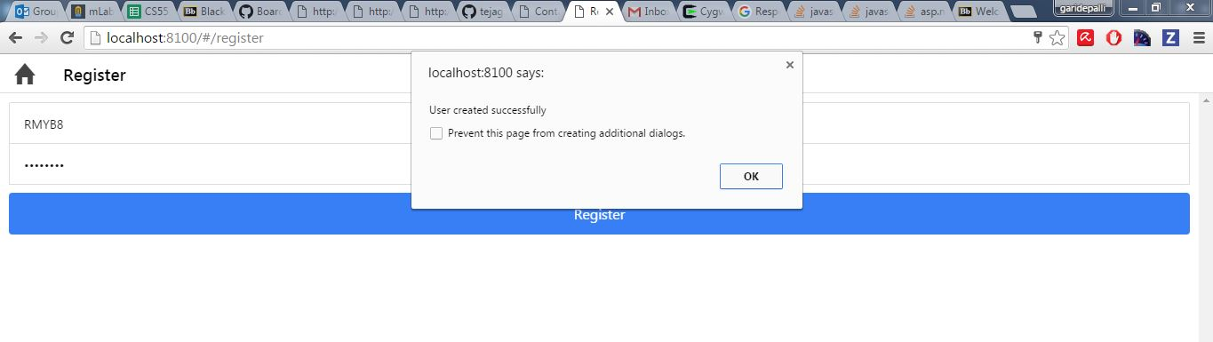

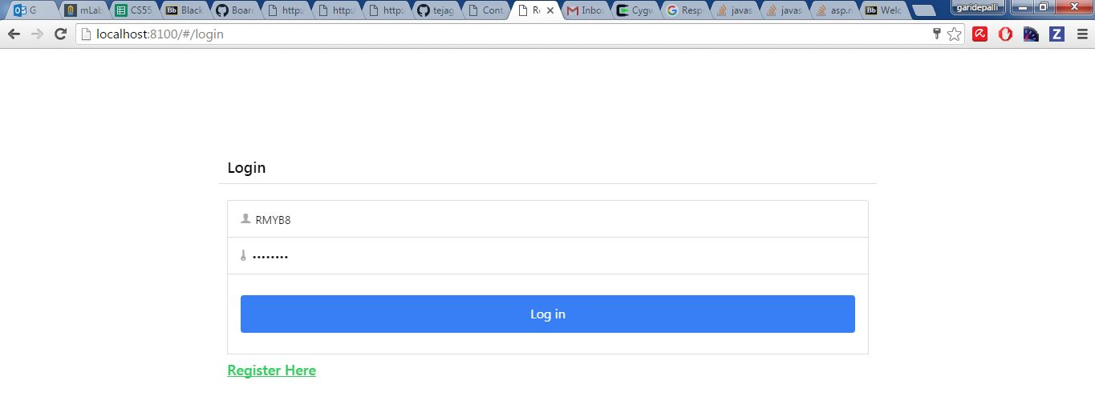

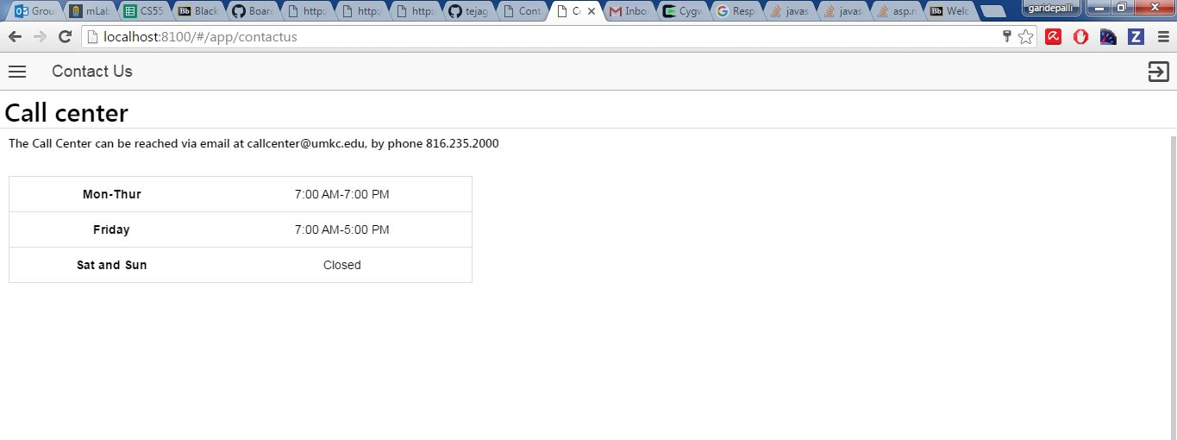

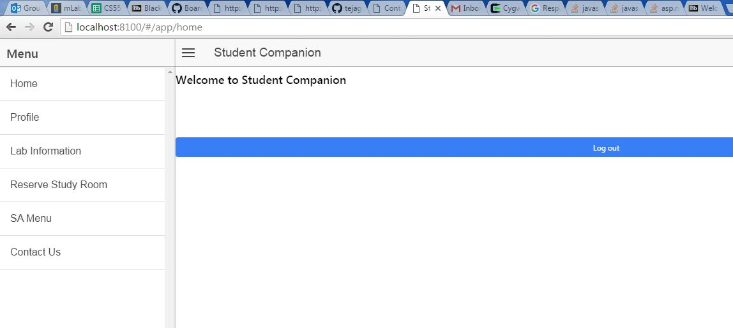

**Project URL:**

https://github.com/meetsriharsha/ASE\_S16\_G7/

**Second Increment Document URL:**

<https://github.com/meetsriharsha/ASE_S16_G7/Documentation>

# Project Management

## Work Completed

In detailed analysis of the system, environment and technical requirements for the application development. Project proposal documentation, Project tasks created in ZenHub and assigned the tasks to team members. Created the Project increment 1 document. All team members are involved in this task. Total time taken is 30 hours per person. Contributions: Harsha 30%, Teja 25%, Raj 25%, Suhas 20%.

## Work To Be Completed

We need to work on login page creation (both UI and logic) and the backend database tables creation. We would like to use mongo db as our database server. Raj Kiran and Harsha will work on login page creation. Teja and Suhas will work on creation of sample database tables. Projected person participation: Harsha 25%, Teja 25%, Raj 25%, Suhas 25%.

Student Companion

Fourth Iteration Report

COMP-SCI 5551 Advanced Software Engineering

# Introduction

This document is intended to provide an overall description of the project named “Student Companion” in detail. The project schedule and the plan of action is also discussed. The proposal document will give an insight on the project. The outcome of the fourth increment is the final web and mobile application with end to end user functionality.

# Project Goal and Objectives

The goal of this project is to provide various functionalities that a student uses regularly such as updating the profile, checking for computer lab availability, library study room reservation etc. The student details will already present in the database. The student has to login before he uses these functionalities. Main objectives of this application are:

* To reduce the student’s stress and to save the student’s time by providing the latest availability of the computer labs.
* To develop an application that helps the students in taking the decision on to which laboratory the students have to go.
* To secure the information by providing a login form to the end user.
* To provide a tool with which the students will be able to reserve the library study rooms.
* To ensure that the student will never miss his schedules by setting reminders.
* To enable the Student Assistants to view their shifts, post and take substitutions.
* To provide the students with the option to update their address or mobile phone number etc.

# Project Background and Related Work

Some functionalities of this application are already exist. We are creating a new android application which integrates (mash up) all the available and new functionalities under one hood, thus making the application a viable one. Some functionalities will be developed by importing the existing APIs into our application like Google Calendar API, Google Maps API etc. We are inspired by the problems that the Students are currently facing in reserving the study rooms, problems related to their working shifts and we came up with a solution which can resolve the existing challenges.

**Significance:**

The major significance of the application lies in mashing up of all the useful services under one system. This will save the student’s time and increases the productivity. The application will prevent the fraudulent usage by restricting the resources access to only the students who successfully logged in to the system. As of now, the student assistants has to go through a lengthy process in order to post or take shifts. The proposed application will make it easier for the student to perform such tasks by providing on-the-go support.

# Work flow

The first workflow of the application is that of the designing the User Interface for the system. Our application goal is to provide instant access to the user regarding lab availability and library room availability. So, for this we are developing a mobile application. We are using ionic framework so that we can develop hybrid application.

Second, we have created the login page and database using MongoLab and we have successfully authenticated the user based on his details which are stored in database in mongodb.

The third workflow deals with the creating a mongodb database to store and retrieve the user profile and information about IS labs, library study rooms etc. The work flow of the each and every feature of the application is explained through sequence diagrams and state chart diagram presented in the first increment report.

Fourth workflow deals with the end to end functional development of the application. Development of each and every feature of the application. Successfully running the application on web browser and in mobile phone.

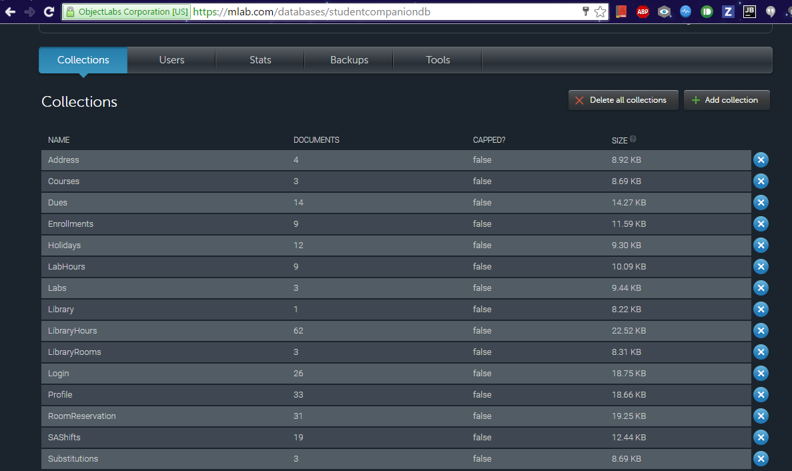

**Fig: Collections in Mongo Database**

# Technological and architecture requirements

In the application system need to interact with the database for retrieving the data to do this interaction between the system and database is done through REST technology. We use CRUD API calls of the REST for accessing the database.

Ionic framework, it is a powerful SDK used to develop hybrid applications using web technologies like HTML, CSS and JavaScript. It is also a core in providing better UI to the user.

The architectural requirement aims at the development of flexible architecture for the better interaction between the system and the database.

# Existing Services/API

We have so far used the MongoDB in our application. MongoDB is a cross-platform document-oriented database and it is a NoSQL database, MongoDB avoids the traditional table-based relational database structure in favor of JSON-like documents with dynamic schemas making the integration of data in certain types of applications easier and faster.

We have used mongoDB to store the information of the users and data about the IS labs, library study rooms, student assistant information etc. Using REST API calls data is retrieved from the database and displayed to the user.

mLab is a fully managed cloud database service that hosts and provide featuring automated provisioning and scaling of MongoDB databases. Data can be accessed from mongoDB using two ways. Fist, by using the DATA APT URL in which it contains database name, collection name and API key.

Example URL: **[https://api.mongolab.com/api/1/databases/studentcorner/collections//Ase\_project/'](https://api.mongolab.com/api/1/databases/studentcorner/collections/Ase_project/'%20+%20id%20+%20'?apiKey=Q_u73BV4oOdMGpnu3WFGmJ8YH_lxHDHO)** [+ id +](https://api.mongolab.com/api/1/databases/studentcorner/collections/Ase_project/'%20+%20id%20+%20'?apiKey=Q_u73BV4oOdMGpnu3WFGmJ8YH_lxHDHO) **['?apiKey=Q\_u73BV4oOdMGpnu3WFGmJ8YH\_lxHDHO](https://api.mongolab.com/api/1/databases/studentcorner/collections/Ase_project/'%20+%20id%20+%20'?apiKey=Q_u73BV4oOdMGpnu3WFGmJ8YH_lxHDHO)**

Second, accessing the mongoDB using a driver to connect the database. An example driver:

mongodb://<dbuser>:<dbpassword>@ds011399.mlab.com:11399/studentcompaniondb

**REST Services:**



**Fig: REST API Communication with mongoDB and Application**

We have developed an API through which we perform the REST services for our application. As in the second increment we have developed database in the mongoLab and the data is fetched from the mongoLab through REST services.

# Amazon Web Services (EC2):

We have used Amazon Web Services as a server to host our REST API. Our REST API will run in background and listen to port 9000. Our application send data request to the REST API hosted on Amazon EC2 cloud server. REST API will fetch the request data from mongoDB collections and perform the filtering of data according to the criteria and sends responds to the client application. This enables us complex queries on the server instead on the client thereby increasing the performance of client application.

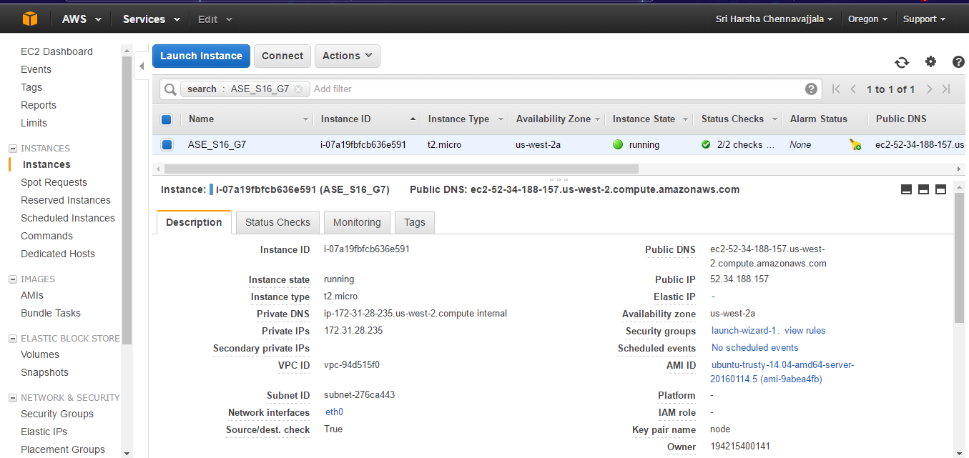

**Fig: Amazon Web Services (EC2) Dashboard - Hosting our REST API**

# Architecture Diagram



**Fig: Architecture Diagram for StudentCompanion application**

The architecture diagram for our application shows that it is 3-tier architecture. Application which deployed in smart phones, PDA’s and Tablet uses the REST services for interacting with the database for storing and retrieval of required information from the mongoDB.

# Project plan

The proposed project plan is outlined the by the screenshot from the ZenHub tool. The project is divided into four milestones. Each iteration has several states namely future tasks, new issues, to do, development in progress, testing in progress, done and closed.



**Fig: ZenHub Board showing the project plan and current tasks.**

**Milestone 4:**

This milestone mainly deals with the designing the end to end functionality of the system. The tasks of this phase mainly focuses six tasks.

First, the development of REST API which performs the communication between Client application and database.

Second, development of Profile page and display the profile of the user which is stored in the mongoDB. Developed the functionalities for register user, edit profile and edit password.

Third, development of Lab Information page and display the Lab name and lab details.

Fourth, development of Reserve Study Room page and display the Library information, study rooms which are reserved by the user and available study rooms and the details of resources present in it and cancellation of reserved study room.

Fifth, development SA Menu page and display the SA Shifts of the user and available shifts on a selected date. Developed the functionality for taking the available substitutions.

Sixth. Implemented the toast functionality for the final application.

The results of this milestone contains the screenshots of the application and the related class, sequence and state chart diagrams.

# Fourth Increment Report

This document contains the report of fourth increment work done on the Student Companion application. This document emphasizes the final end to end implementation of the application using different technologies such as REST API, Amazon Web Services, Ionic framework and mongoDB. We’re using the HTML5, CSS ,Node.js, , ExpressJS and Angular JS for the end to end implementation.

We have created REST API which host on the Amazon Web Services through which communication between client application and database.

We have created the Profile, Register, Edit Profile, Lab Information, Reserve Study Room, SA Menu, Contact Us pages. We have also checked the work so far by deploying the application in the mobile and manual testing is done.

The detail development in fourth increment include the enhancement of Profile, Lab Information, Reserve Study Room, SA Menu, Contact Us pages and development of Register and Edit Profile pages. Developed an icon for the application.

**Class diagram for the high level design of the application:**

****

**Fig: Demonstrates a class diagram of high level design of application**

**Sequence diagrams for the high level design of the application:**

****

**Fig: Sequence diagram for student login activity**

****

**Fig: Sequence diagram shows the control flow for “view user profile” task**



**Fig: Sequence diagram for “View lab information” activity**



**Fig: Sequence diagram for reserving library study room activity**



**Fig: Sequence diagram for student assistant activities like post or take shifts.**



**Fig: State chart diagram for the application modules.**

## Wireframes of the application:



**Fig: Login screen**



**Fig: Main Home page**



**Fig: Side menu bar**



**Fig: Computer Labs information page**



**Fig: Detailed information of a computer lab**



**Fig: Library study room information**



**Fig: Library room reservation page**



**Fig: Library room reservation form**



**Fig: Student Assistant menu page**



**Fig: Taking a Student Assistant shift**



**Fig: Posting a Student Assistant shift**



**Fig: Student profile page**



**Fig: Contact Us information page**

**User Stories:**

* As a User, I can see the UI of StudentCompanion App.
* As a user, I can see the Login Screen.
* As a user, I can enter my Details and Login to the App.
* As a user, I can see the Side menu bar on Home Page with side menu options like Profile, Lab Information, Reserve Study Room, and SA Menu.
* As a User, I can see my Profile.
* As a User, I can see the Lab Information of specified lab.
* As a User, I can Reserve Study Room.
* As a User, I can choose the SA Menu option
* As a User, I can utilize the options in SA Menu.
* As a user, I can Sign-out from the Application.

# Testing

We’ve used *YSlow* - a Google Chrome extension to test the performance of our application. It shows the requests and their weights in a graphical manner. This helped us to tweak our code to improve the application overall performance.

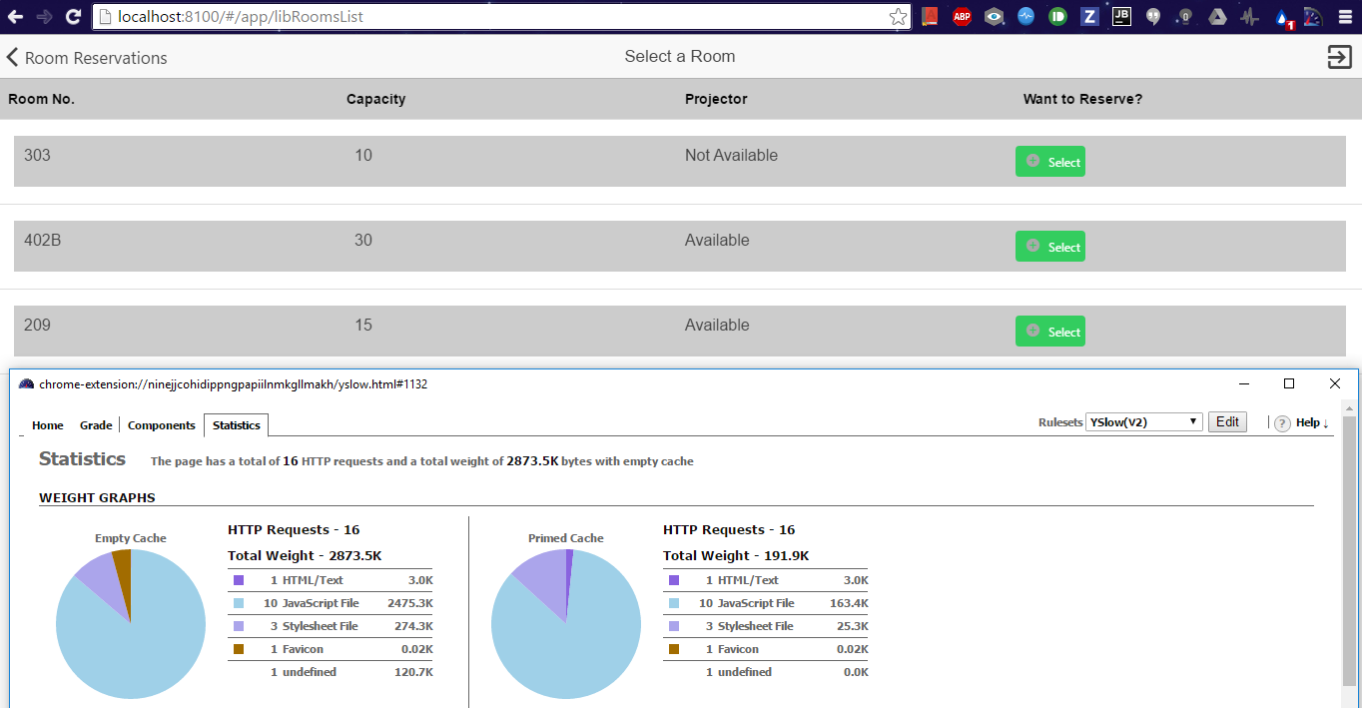

**Fig: YSlow statistic of “Room Reservation” page**

# Deployment

Deployment of application to Mobile phone.

Screen Shots:

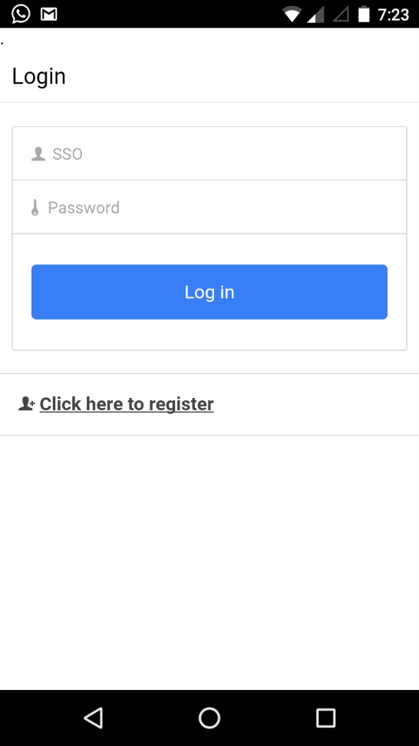 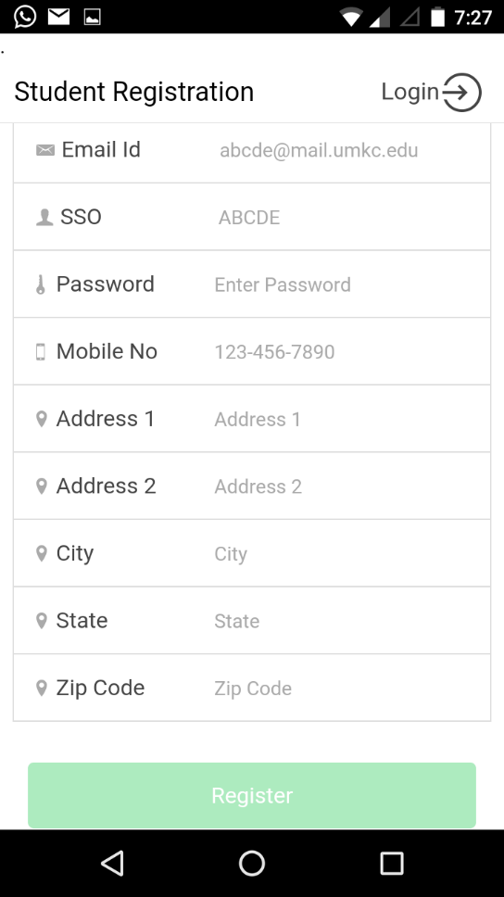

**Fig: Login Fig: Register User**

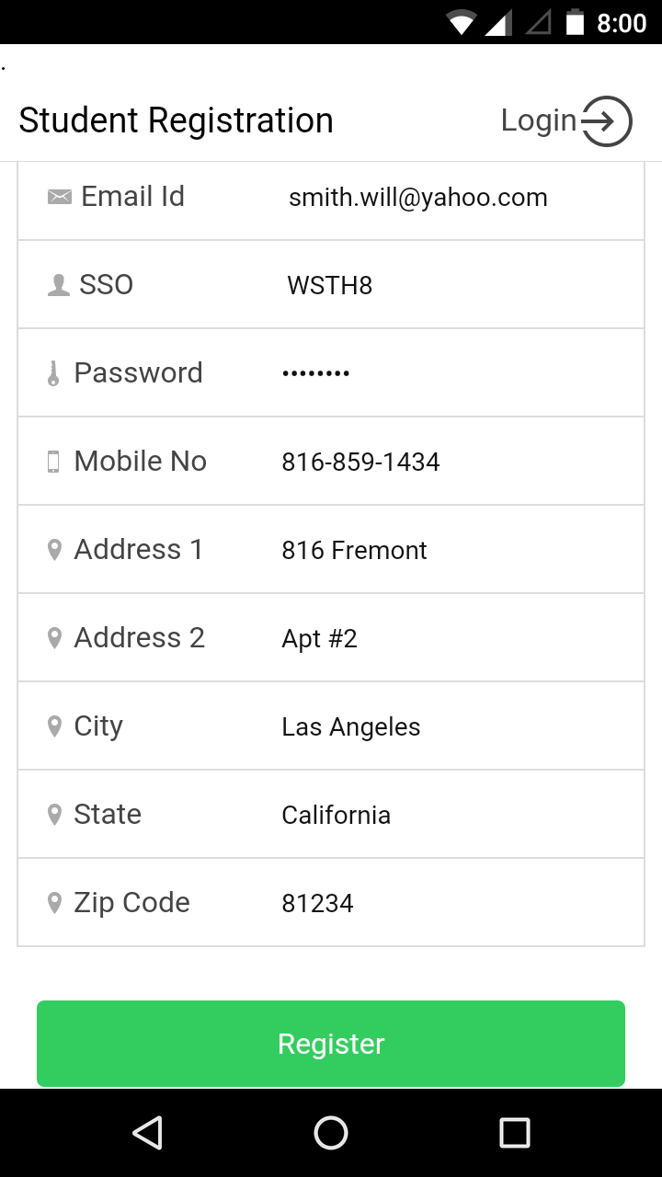 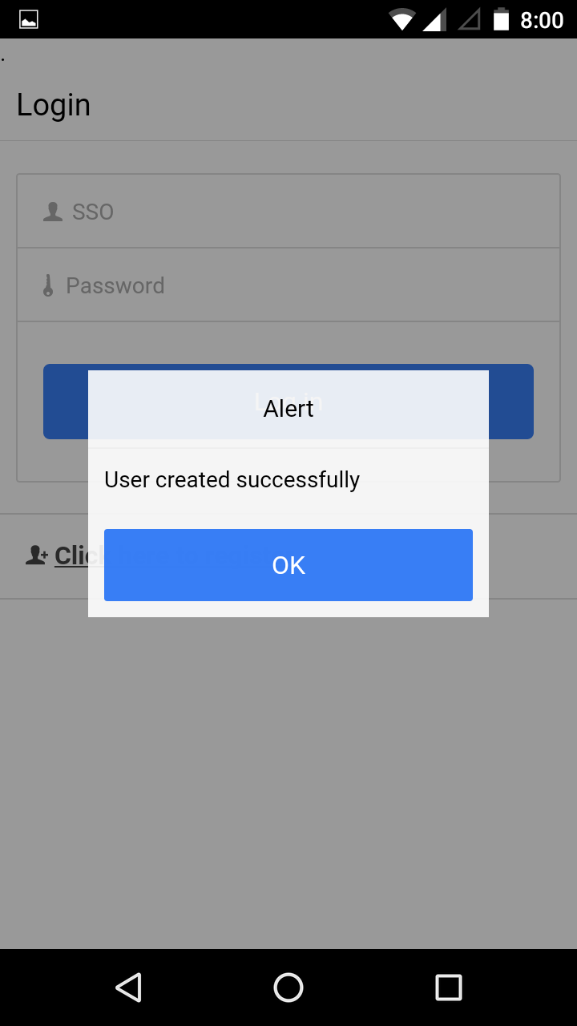

**Fig: User Details Fig: User Registered**

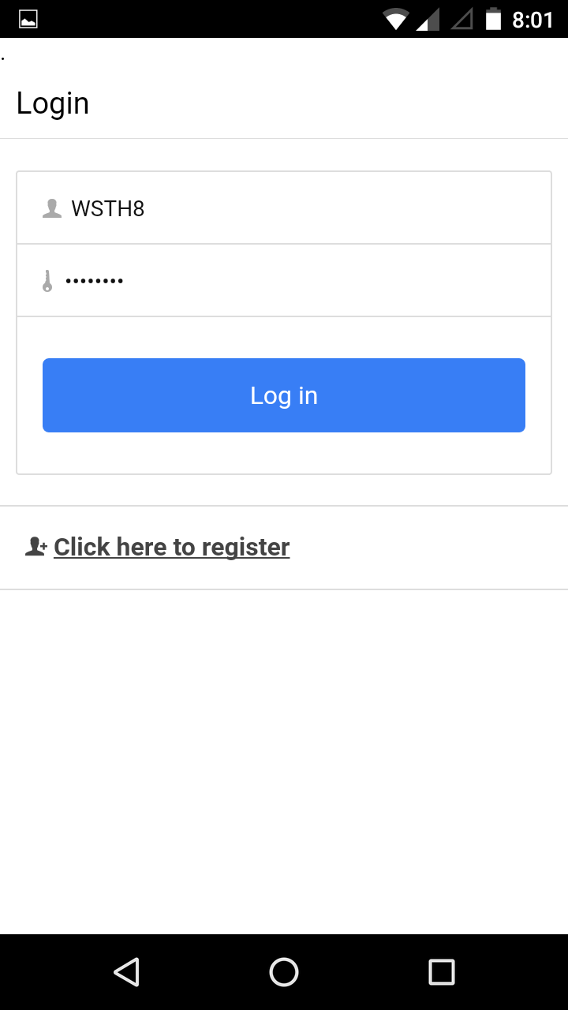 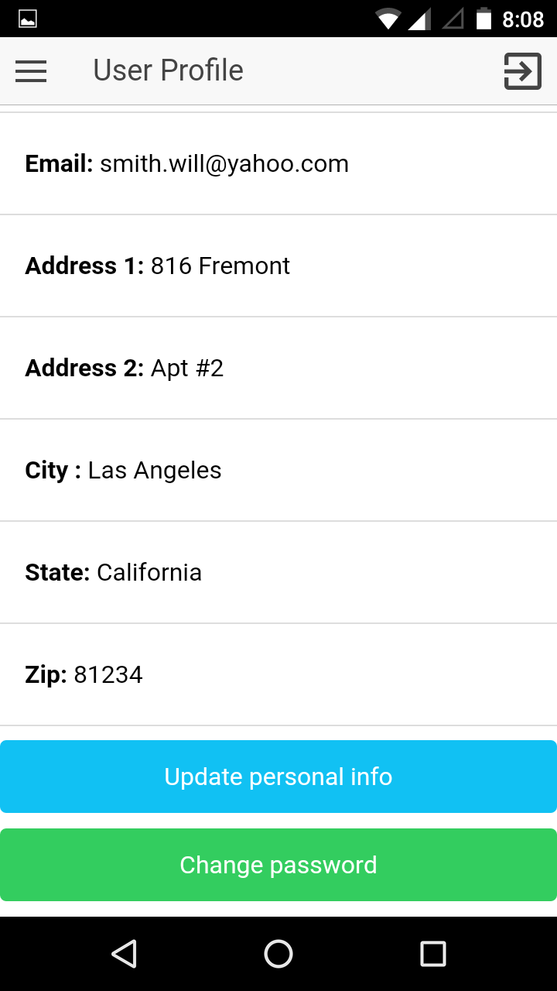

**Fig: Login Success Fig: User Profile**

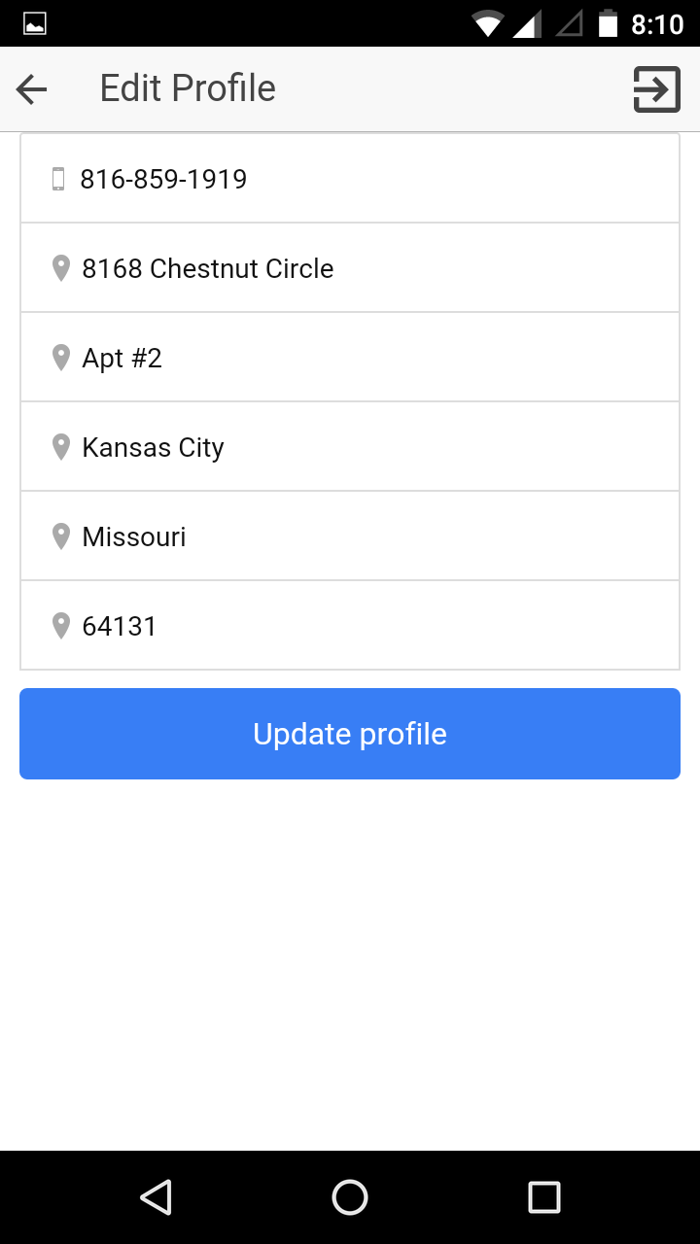 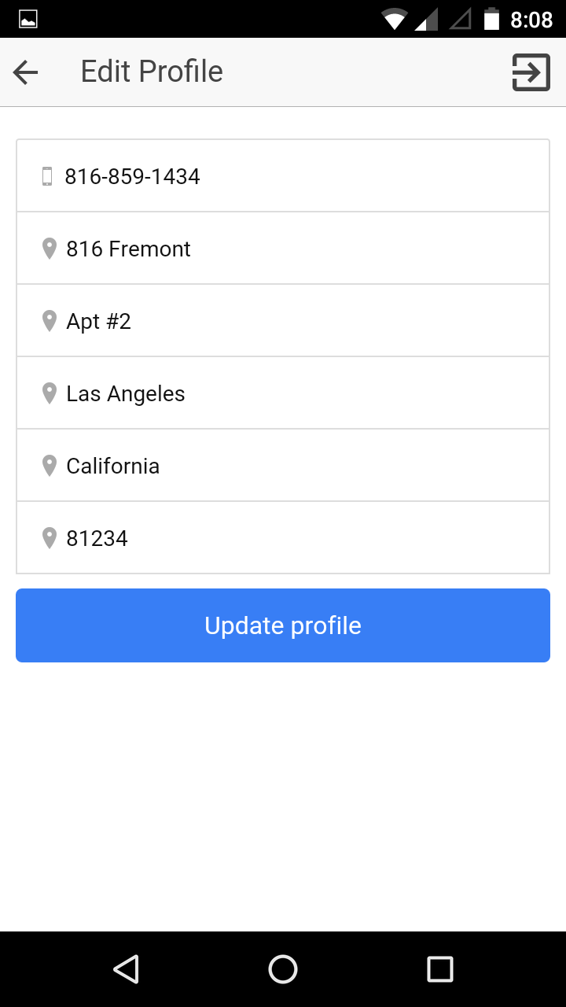

**Fig: Initial Details Fig: Updated Fields**

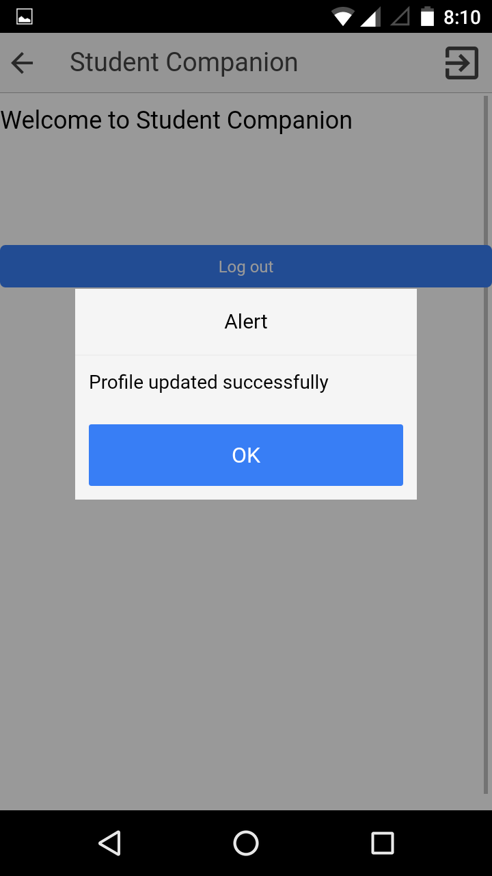 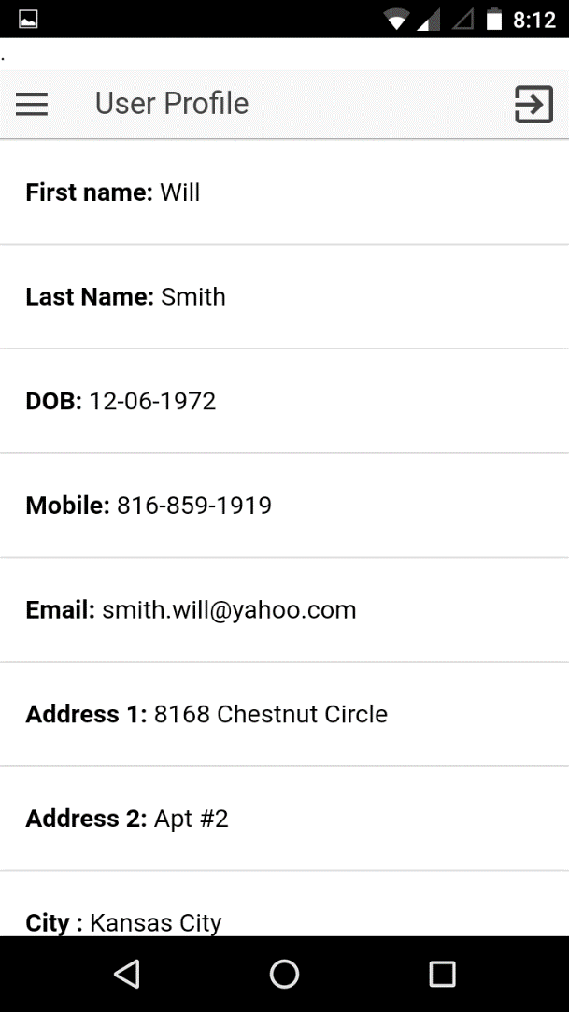

**Fig: Profile Updated Fig: Updated Profile**

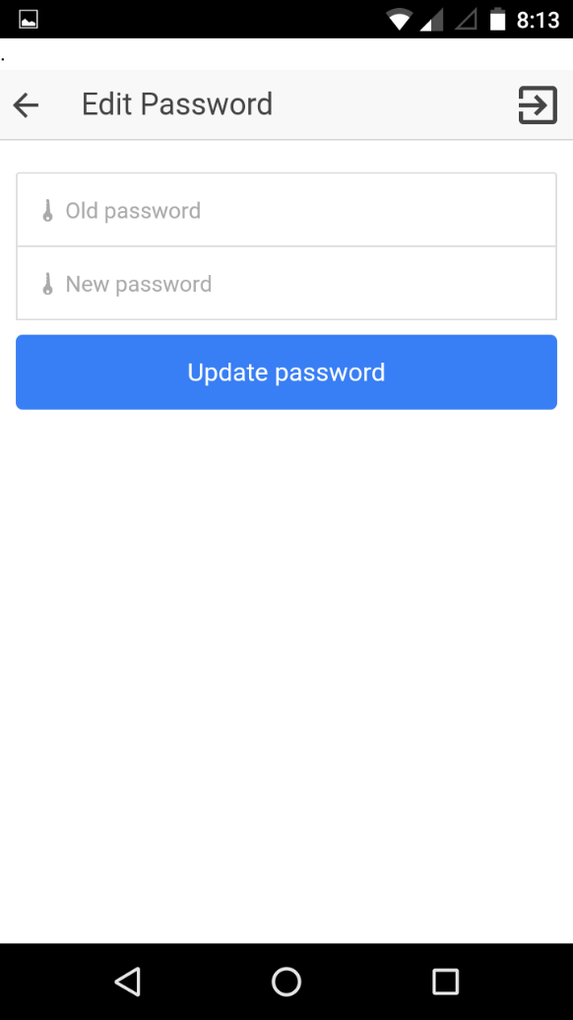 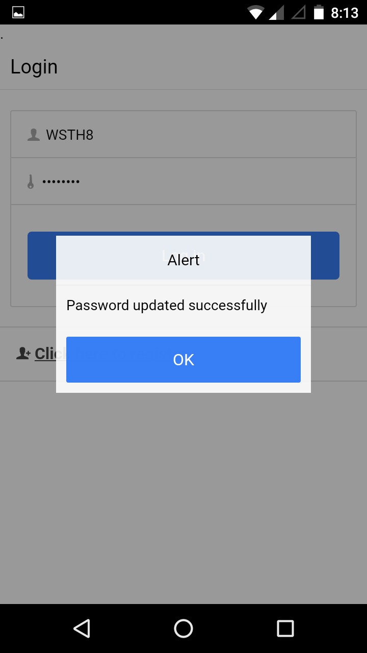

**Fig Edit Password Fig: Password Updated**

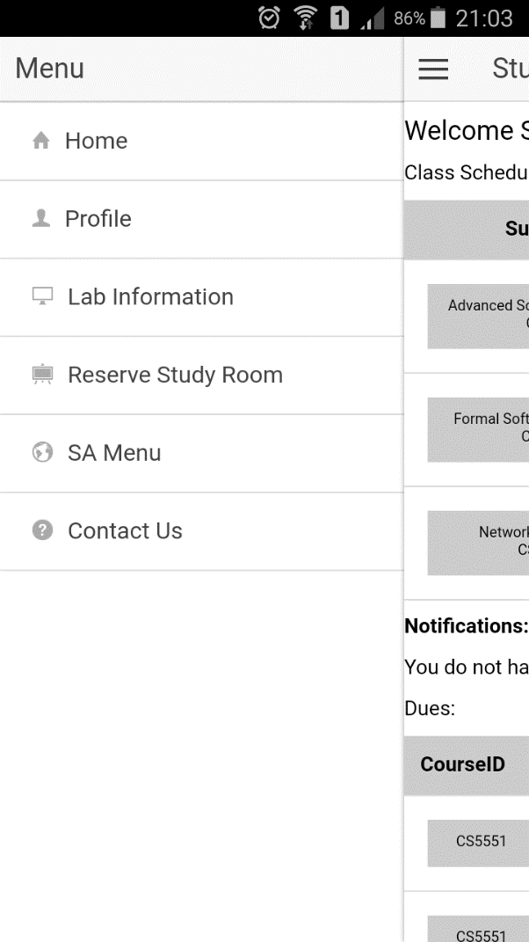 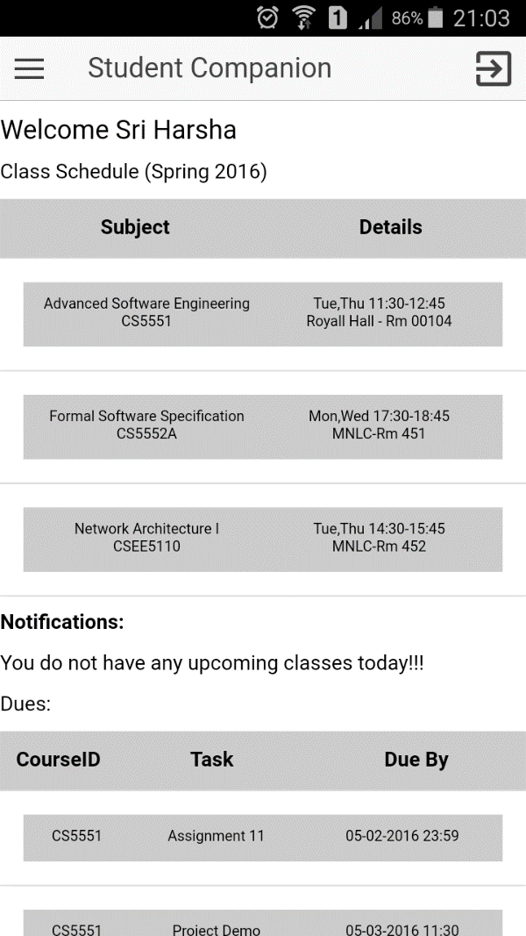

**Fig: Side Menu Fig: Home Page**

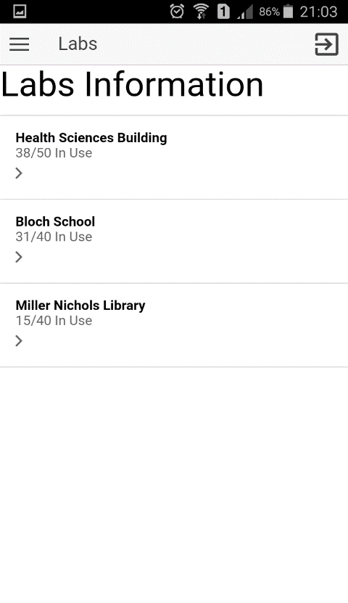 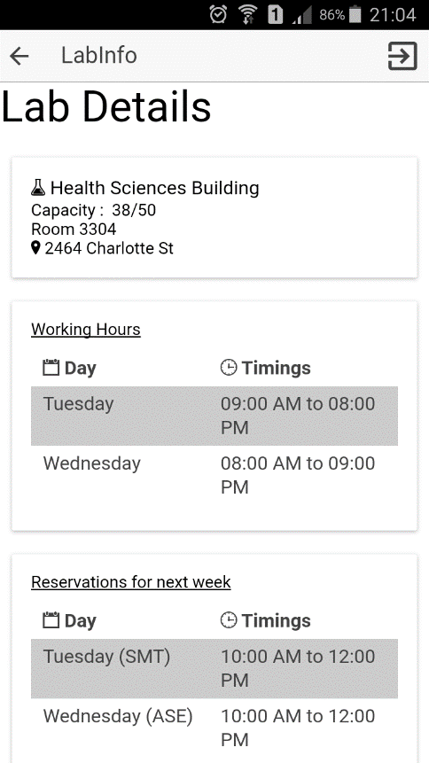

**Fig: Lab Information Fig: Lab Details**

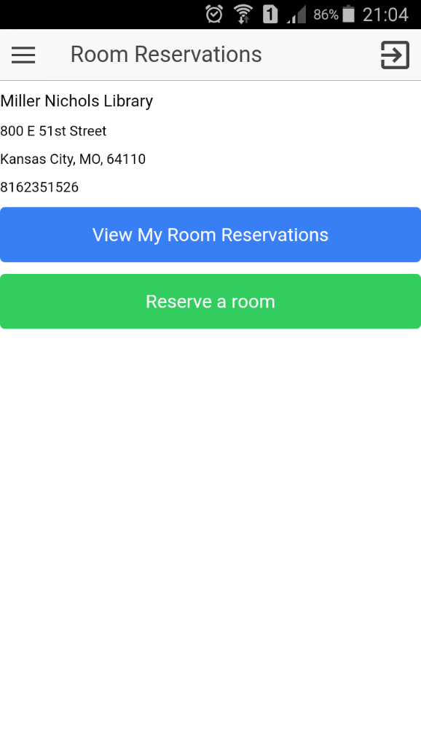 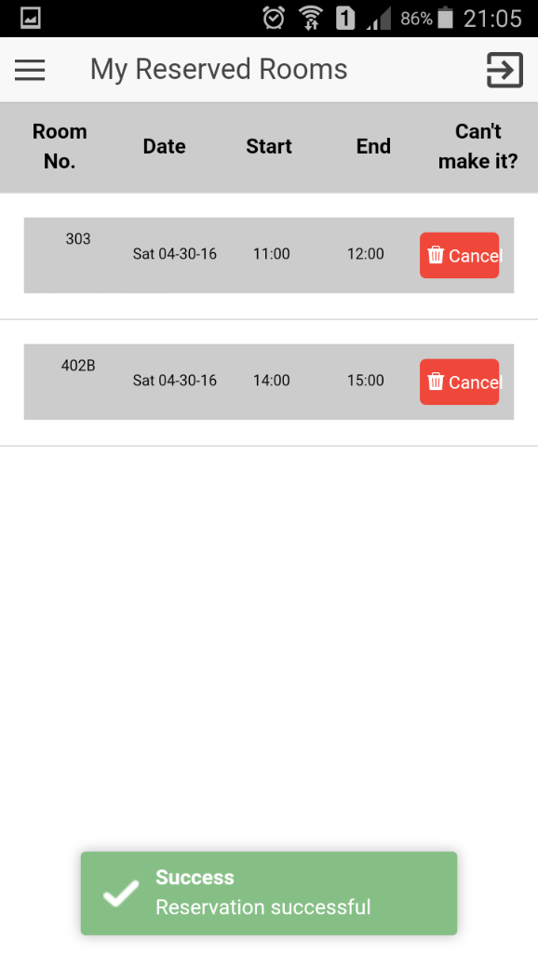

**Fig: Room Reservation Fig: View My Reservations**

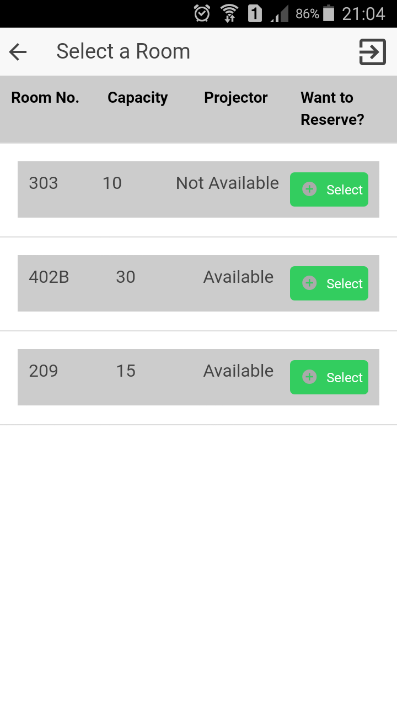 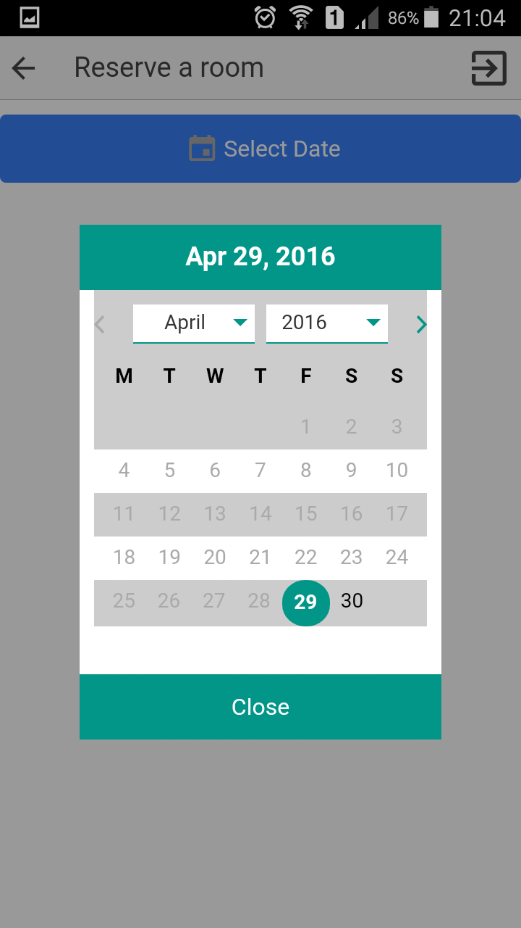

**Fig: Select a Room Fig: Select Date**

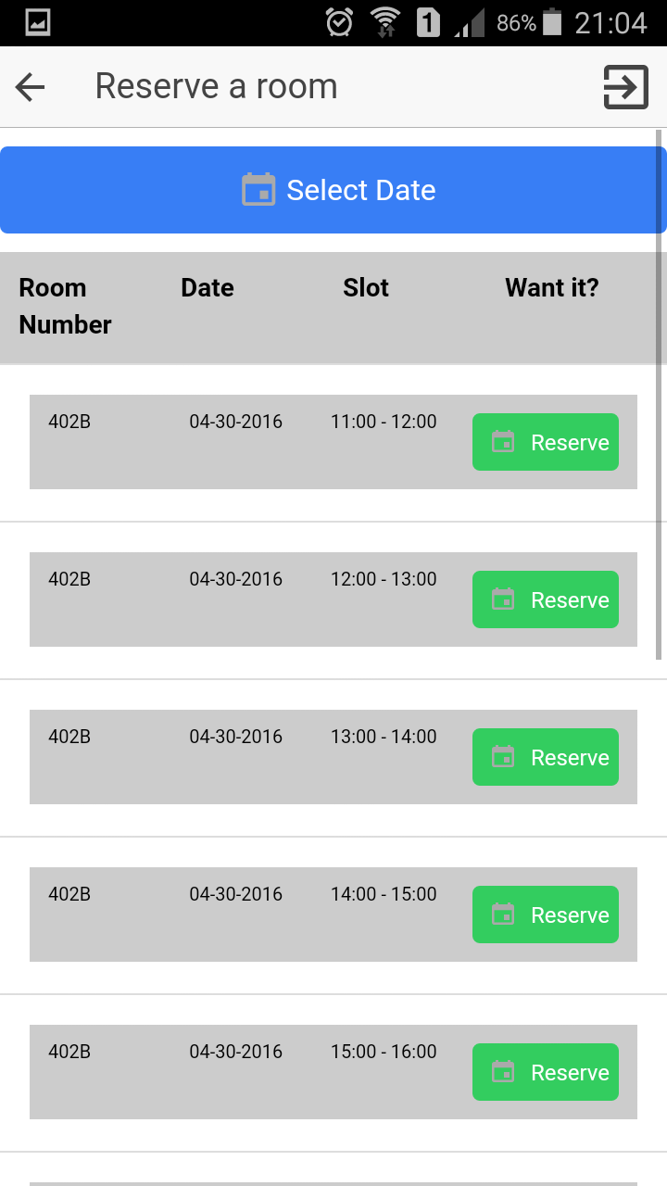 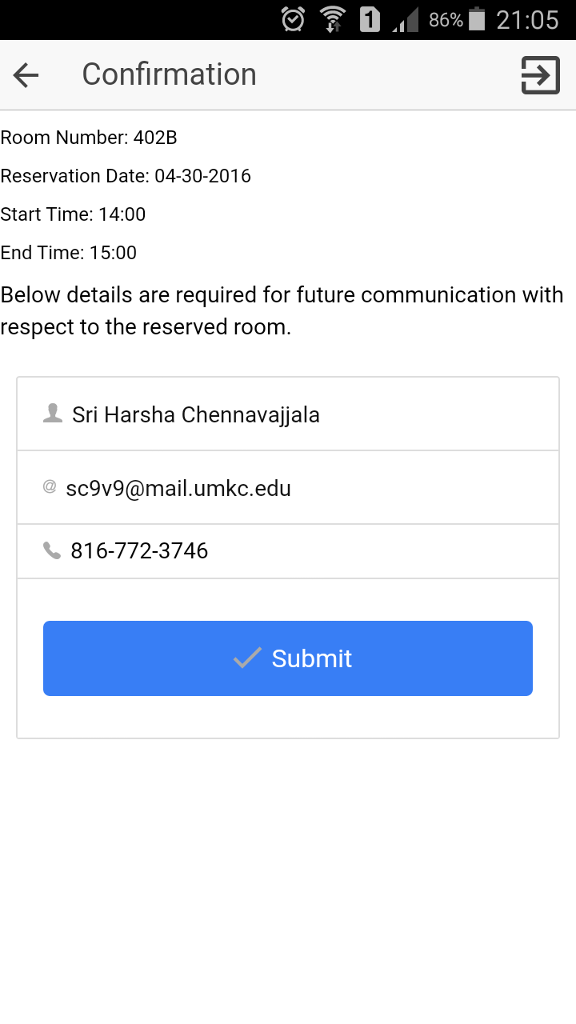

**Fig: Select a Reservation Slot Fig: Room Reserve Confirmation**

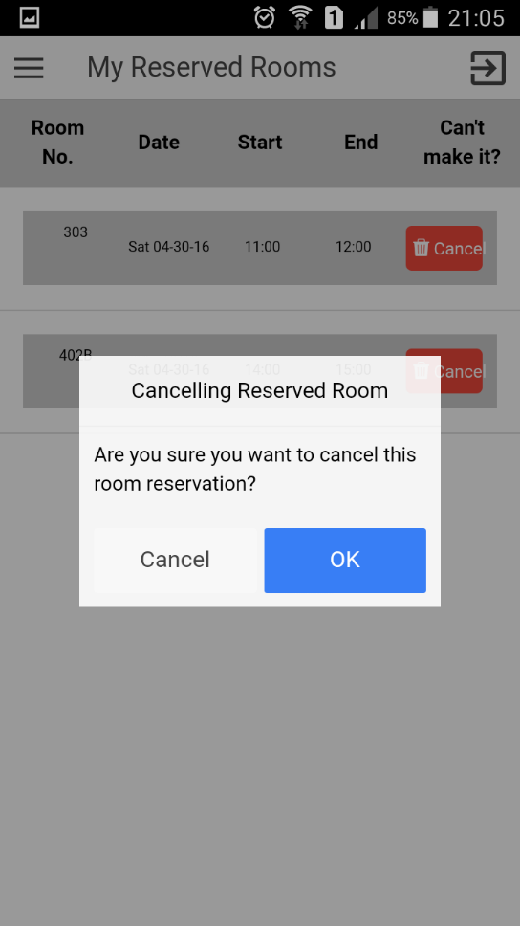 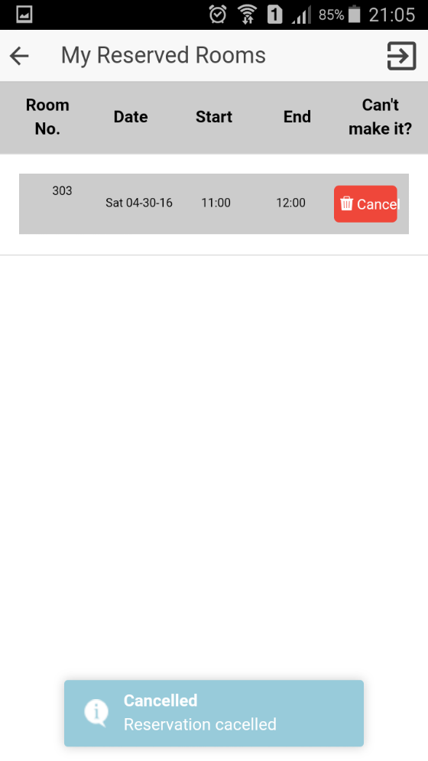

**Fig: Room Cancellation Fig: Room Cancellation**

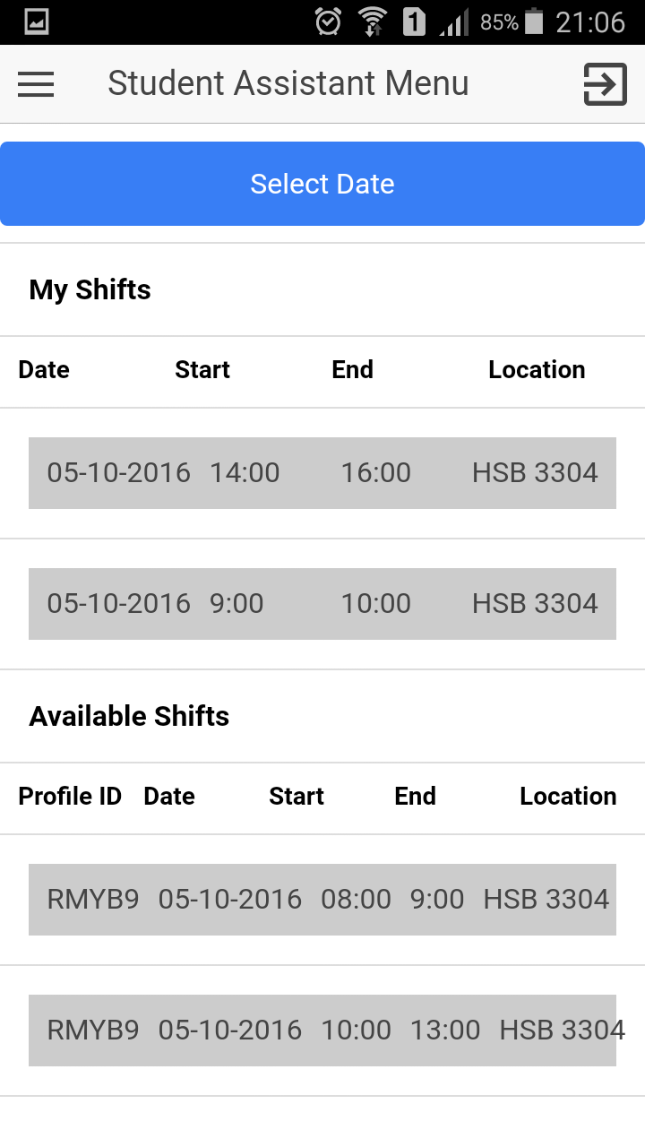 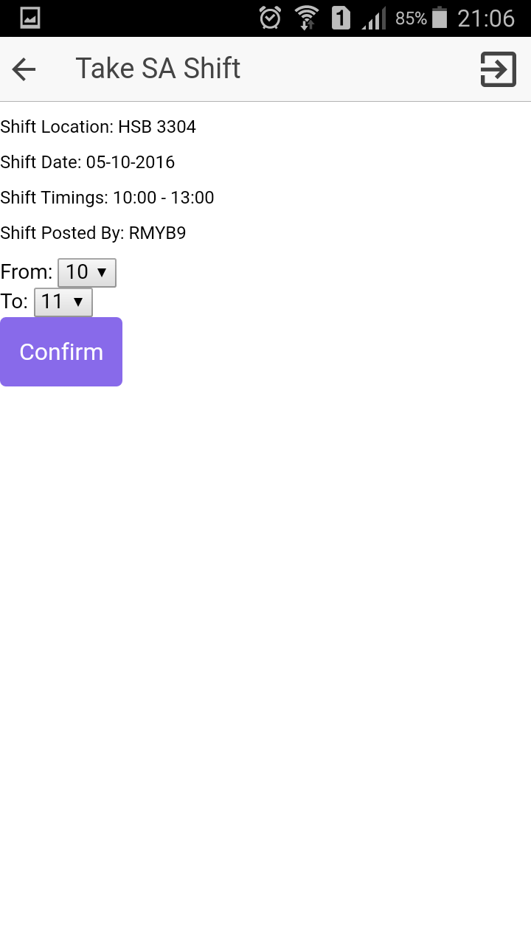

**Fig: View Shifts Fig: Take Shift**

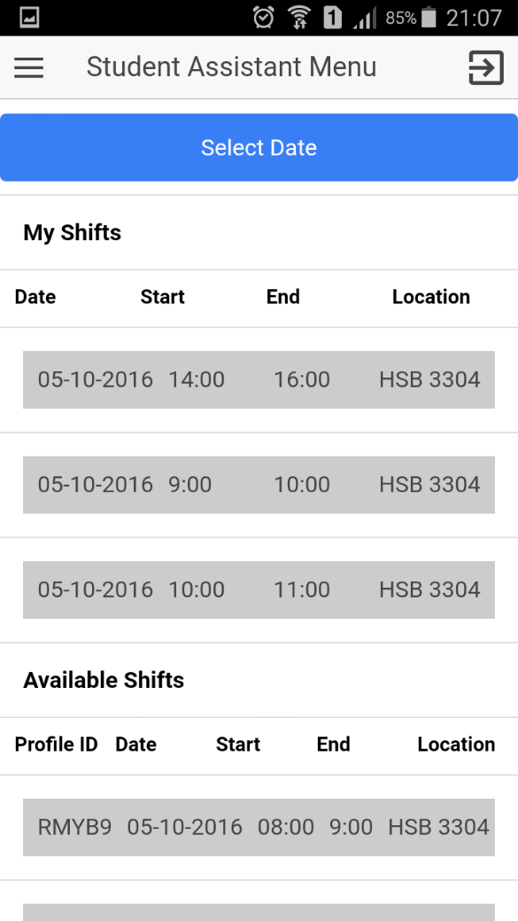 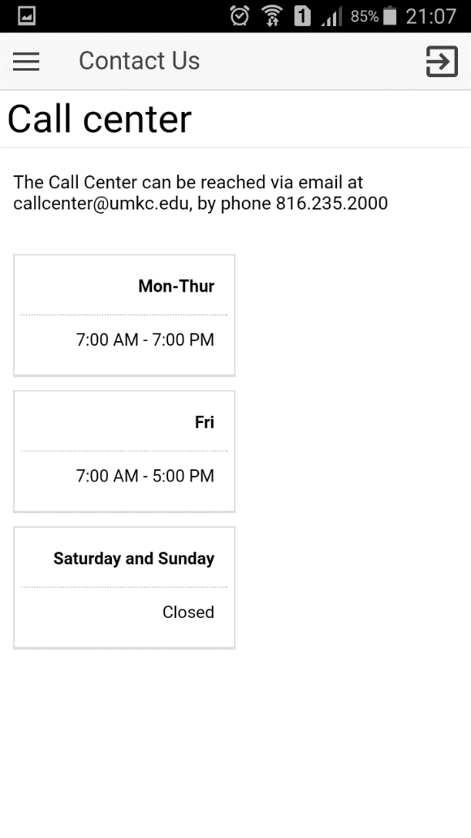

**Fig: After Take Shift Fig: Contact Us**

**Web Application Views:**

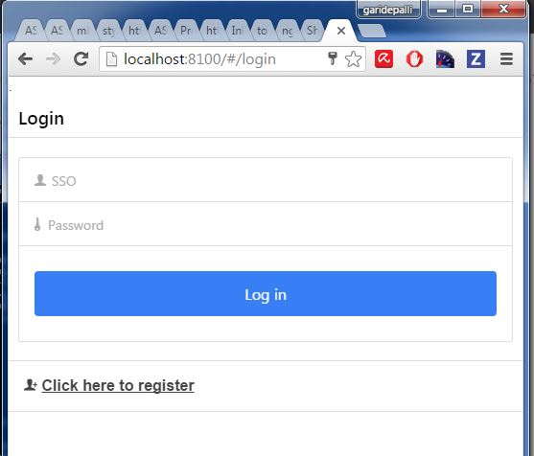

**Fig: Login**

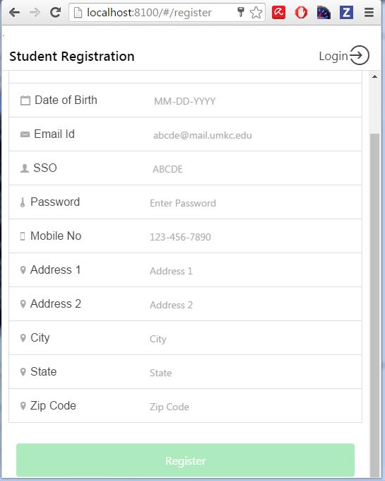

**Fig: Registration**

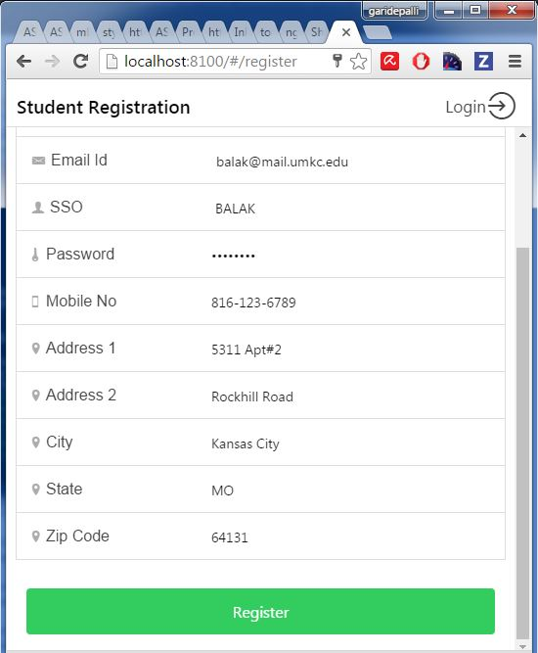

**Fig: Student Registration**

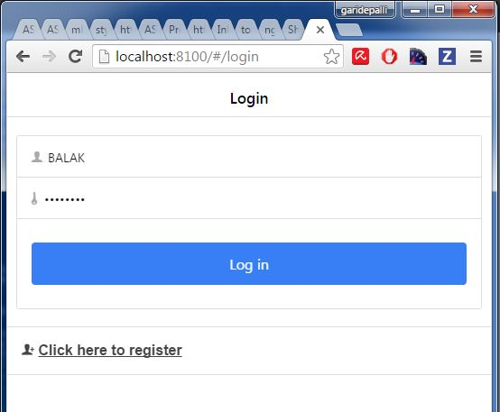

**Fig: Registered User Login**

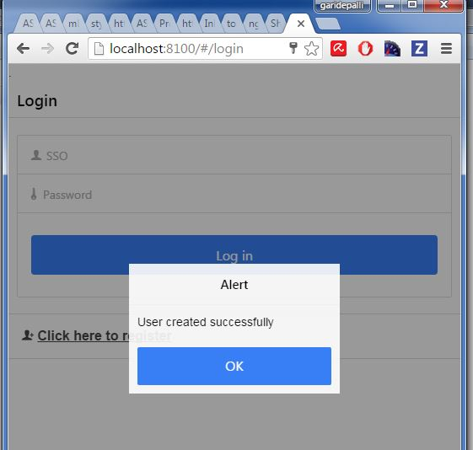

**Fig: Login Success**

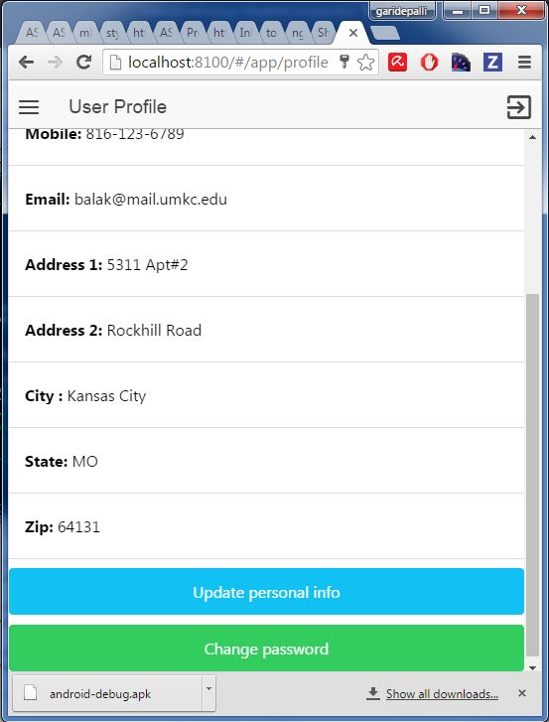

**Fig: View Profile**

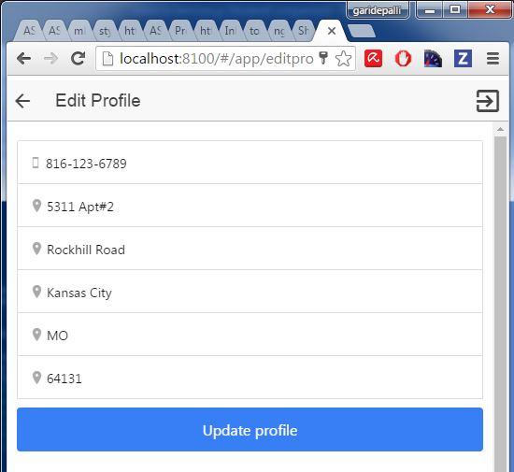

**Fig: Edit Profile**

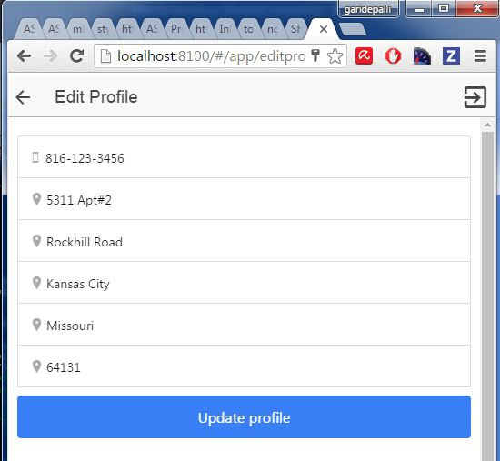

**Fig: Profile Updated**

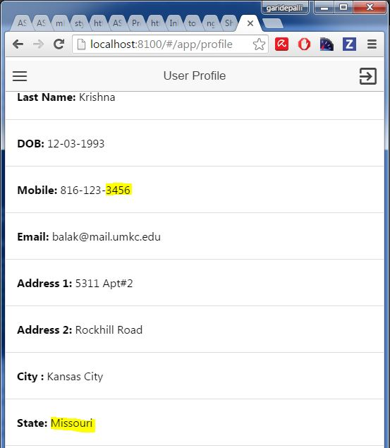

**Fig: Updated View**

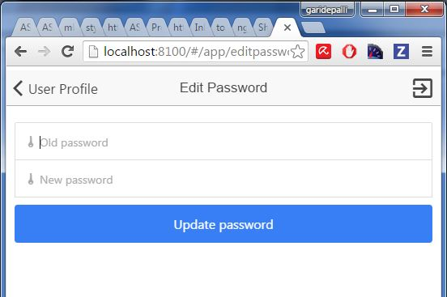

**Fig: Edit Password**

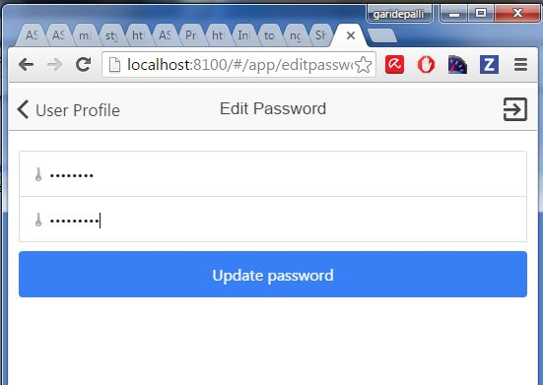

**Fig: Updated Password**

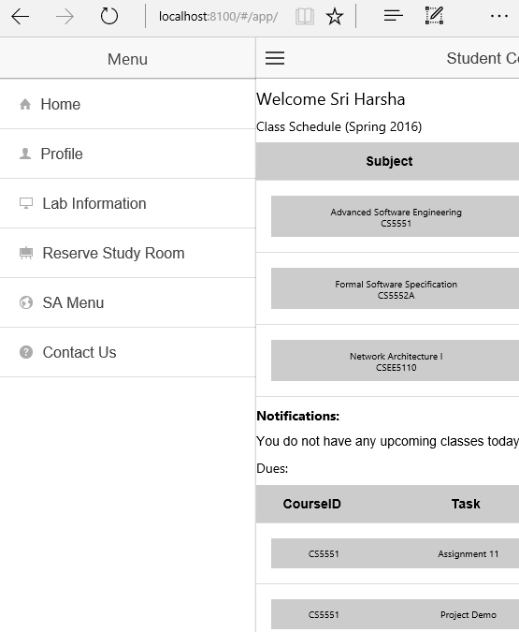

**Fig: Side Menu**

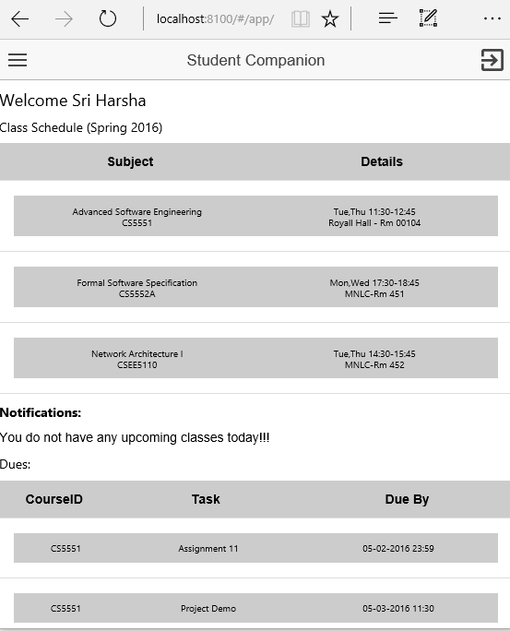

**Fig: Home Page**

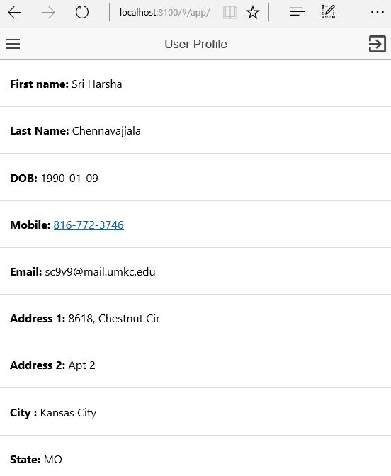

**Fig: Profile**

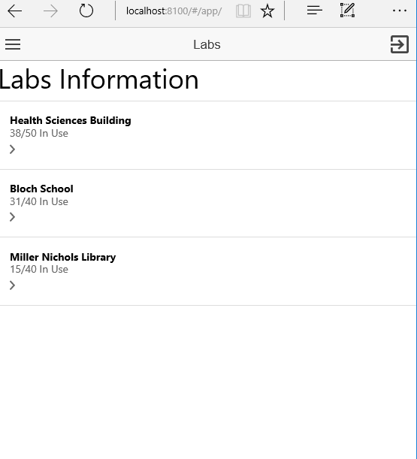

**Fig: Lab Information**

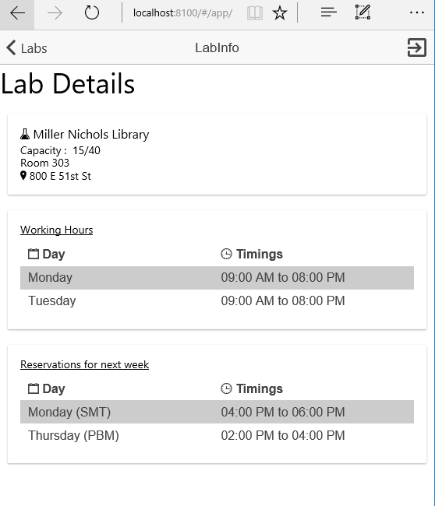

**Fig: Lab Details**

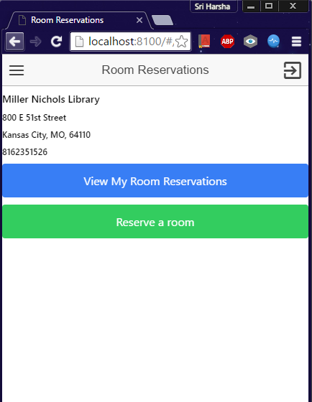

**Fig: Room Reservation**



**Fig: View Reserved Rooms**



**Fig: Available Rooms**



**Fig: Select Date**



**Fig: Available Rooms**



**Fig: Available Slots**



**Fig: Confirm Reservation**

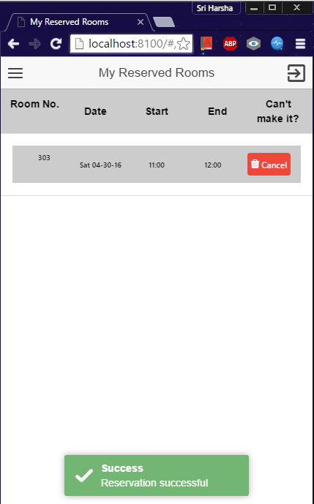

**Fig: Room Confirmation Toast**



**Fig: SA Menu**



**Fig: Take Shift**



**Fig: After Take Shift**



**Fig: Contact Us**

**Project URL:**

<https://github.com/meetsriharsha/ASE_S16_G7/>

**Document URL:**

<https://github.com/meetsriharsha/ASE_S16_G7/Documentation>

# Project Management

## Work Completed

In detailed analysis of the system, environment and technical requirements for the application development. Project proposal documentation, Project tasks created in ZenHub and assigned the tasks to team members. Created the Project increment 4 document. All team members are involved in this task. Total time taken is 30 hours per person. Contributions: Harsha 30%, Teja 25%, Raj 25%, Suhas 20%.

Limitations:

The data which we worked on is a static database so the test cases that we performed on the application may not be accurate or sufficient. As we used ionic frame work for the development of application we have some limitations on the core functionalities of the mobile phones.

## Issues/Concerns:

Sometimes we are getting black background for the login page due to some unknown big in ionic framework. Sometimes we are getting asynchronous results from API in Home page.

Burndown Chart for Increment 4:

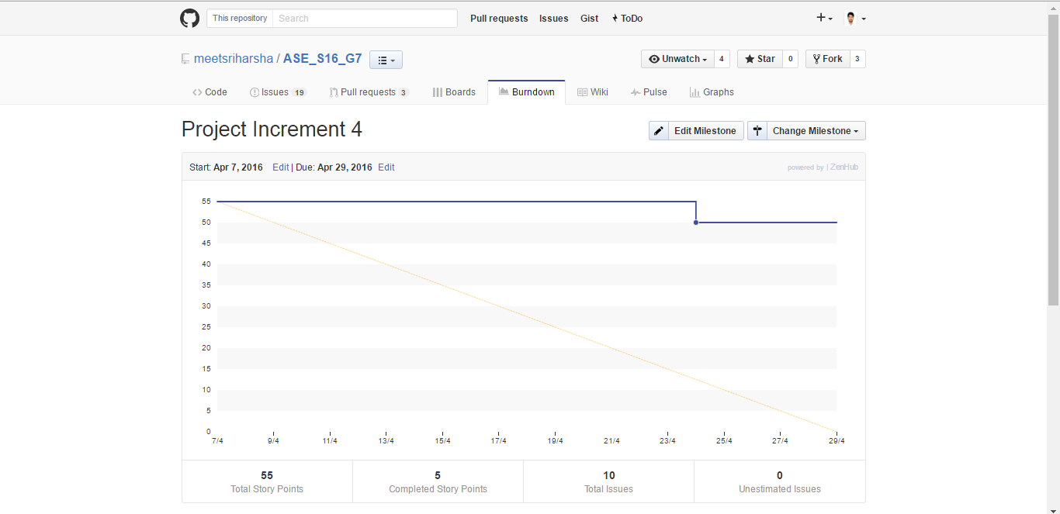

Fig: Burndown Chart

Student Companion

Presentation Slides

COMP-SCI 5551 Advanced Software Engineering



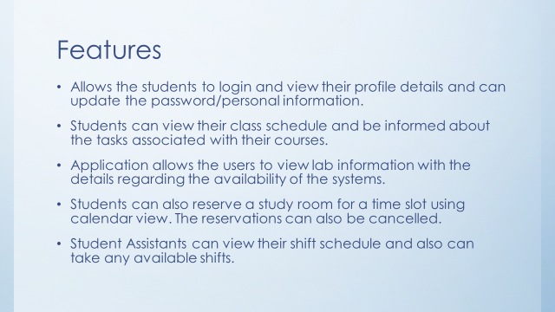

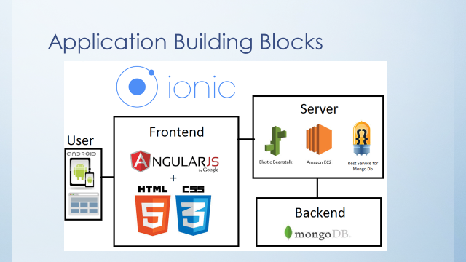

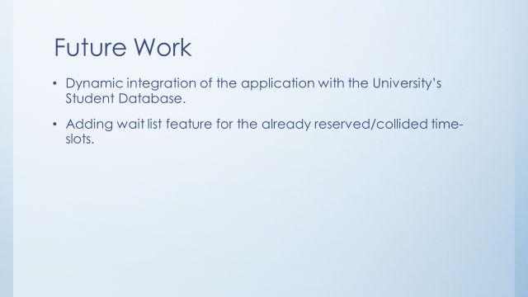

Git Hub URL: <https://github.com/SCE-UMKC/ASESP16_StudentCompanion_Team7>

YouTube Video URL: <https://www.youtube.com/watch?v=v6NcbSS8hcQ>